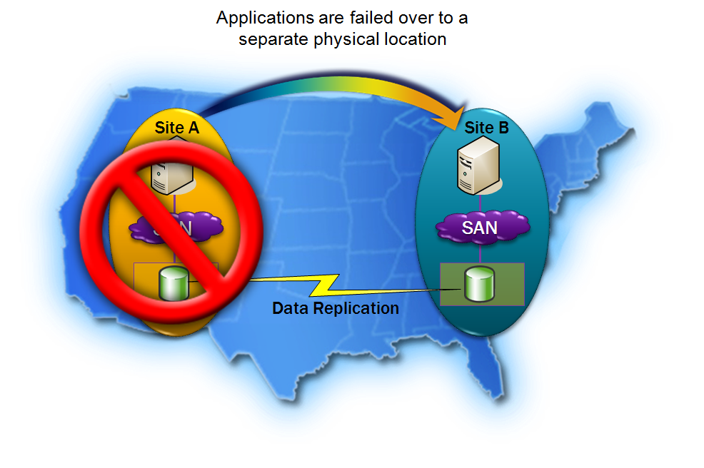

The success of your business increasingly relies on your servers for business-critical operations. As a result, server availability is a higher priority than ever. Windows Server® 2008 makes possible the server high availability required by your business through features including failover clustering.

Failover clustering in Windows Server 2008 includes new improvements to the cluster infrastructure, such as cluster validation and enhanced support for multi-site clustering. For e-mail, databases, line-of-business applications, and other workloads that need to be highly available and disaster tolerant, Windows Server 2008 failover clusters let you make the most of your network configuration and maximize the availability of user services.
www.microsoft.com/
windowsserver2008/
failover-clusters.mspx

Simplifying Clusters
Microsoft® Windows Server 2008 failover clusters make it easier to configure server clusters, making them more secure, enhancing their stability, and reducing your total cost of ownership. Failover clustering in Windows Server 2008 lets you ensure that your mission-critical applications and services such as e-mail and line-of-business applications have the high availability required by your business.

Windows Server 2008 failover clusters are also affordable. Comparable high-availability solutions can cost thousands of dollars—failover clustering comes included in the enhanced-capability editions of Windows Server 2008, such as Windows Server 2008 Enterprise. Ease of deployment and affordability make Windows Server 2008 an ideal high-availability solution for organizations of all sizes.

Supporting up to 16 nodes per cluster, the failover cluster feature of Windows Server 2008 doubles the scalability previously available in Windows Server 2003.

New or enhanced features include Cluster Validation, revamped setup and deployment, networking enhancements, improved cluster management, WMI-enabled full scriptability, cluster migration, high availability through improved cluster infrastructure, new security and quorum models, improvements to eliminate failure points, updates to storage, and enhancements for geographically dispersed clusters.
Windows Server 2008 failover clusters give you:
- More control through enhanced configuration, management, and diagnostics.
- Increased protection through improved authentication and encryption.
- Greater flexibility through expanded networking, management, and storage features.

More Control
Setting up and managing clusters is now easier than ever, helping you eliminate single points of failure to your critical applications and ensuring higher workload availability.

The Cluster Validation wizard analyzes your server, storage, and network configurations to identify and resolve potential barriers to setting up clusters.

Validate also tests your cluster to confirm the consistency of your operating systems and server software, examines the network to determine whether redundancy requirements are being met, and establishes the ability of the cluster mass storage to support cluster commands and actions.

Because you can run a Cluster Validation session at any time, it provides valuable and easy insight for troubleshooting.

Cluster setup has been enhanced to make it easier to initiate a new cluster. Setup is also fully scriptable, to help you automate your cluster deployments.

Increased Protection
Among the new security enhancements in Microsoft Windows Server 2008, Failover Clustering uses Kerberos to provide strong, enterprise-quality authentication and encryption.

An enhanced mechanism to use Persistent Reservations and a new algorithm for managing shared disks means that Windows Server no longer uses SCSI Bus Resets, which can be disruptive on a storage area network (SAN). With Windows Server 2008 failover clusters, disks are never left in an unprotected state.

Failover clustering in Windows Server 2008 also features an enhanced security model, in which the Cluster Service runs in the context of the LocalSystem built-in account, making account password management easier. There is also an auditing feature that enables you to capture data on who is accessing your clusters and when.
Other security features of failover clustering in Windows Server 2008 include improved disk fencing for shared disks and inter-node communication encryption.

The Windows Server 2008 failover cluster feature helps increase protection through:
- Advanced cluster availability
- Better administration and insight
- Stronger encryption and management of shared disks

Greater Flexibility
Failover clustering in Windows Server 2008 provides new failover cluster enhancements that offer the flexibility to adapt to changing business needs.

In addition to providing availability for traditional node and/or application failure, multi-site clusters provide true disaster tolerance. Failover clusters in Windows Server 2008 support geographically dispersed nodes and enable them to communicate across subnets, avoiding the limitations of extending virtual LANs (VLANs).
In addition to providing local access for clients spread across a wide geographic area, multi-site clustering also enables you to make the most of your clusters, taking them from a high availability option to a component of your disaster recovery solution.

The improved management in Windows Server 2008 failover clusters enables you to easily add clustered resources to a network configuration, and to identify and troubleshoot problems with verbose cluster logging and with Event Tracking for Windows®.

You have an automatic view of shared folders, so it is easy to understand which shared folders are clustered, and on which cluster a shared folder is available.

You can use the command line or Windows Management Instrumentation (WMI) to perform tasks associated with clusters and easily back up and restore cluster
configurations using the Volume Shadow Copy Service.
Windows Server 2008 failover clusters also offer network advances, simplifying transport of Server Message Block (SMB) traffic using Domain Name System (DNS), and facilitating node-to-node and node-to-client communication with Internet Protocol version 6 (IPv6).

Enhancements to storage in failover clustering in Windows Server 2008 include:
- The ability to modify resource dependencies while resources are online without interrupting access to mission-critical applications.
- Support for Serial Attached SCSI (SAS) mass storage, a reliable, low-cost solution for cluster storage.
- The option to extend storage performance by utilizing either GUID partition table (GPT) disks or master boot record (MBR) disks.

Failover clusters in Windows Server 2008 provide a high-availability solution with flexibility to meet changing business needs. Windows Server 2008 failover clusters:
- Support multi-site clustering for disaster recovery.
- Offer improved disk maintenance without cluster disruption.
- Provide enhanced network traffic and communication capabilities.
- Extend storage and enables easy resource modifications.

More Information
For additional information about Windows Server 2008 Failover Clustering, please visit www.microsoft.com/
windowsserver2008/
failover-clusters.mspx

