Using AAM URL Redirection As Part of the Upgrade Process
Author:
Sean Livingston
Date published:
November 2009
Summary:
This white paper describes the planning activities that you need to successfully deploy and use the alternate access mapping (AAM) URL redirection feature in SharePoint Server 2010 or SharePoint Foundation 2010 to help mitigate downtime during a server computer or server farm upgrade. It also describes the procedures necessary to successfully complete the configuration of this feature by modifying existing Office SharePoint Server 2007 or Windows SharePoint Services version 3.0 server computers.

Important: The process described in this white paper is an advanced technique for avoiding downtime during upgrade. It should only be used if other techniques, such as read-only databases and parallel database attach upgrade, would cause an unacceptably long period of downtime for your users. Do not consider using this technique unless you know your upgrade process will take more than a long weekend. If your upgrade is not likely to take that long, you won't save any time by performing the procedures in this paper. For more information about other approaches to upgrade, see Determine upgrade approach (SharePoint Server 2010) (http://go.microsoft.com/fwlink/?LinkId=169504) or Determine upgrade approach (SharePoint Foundation) ( http://go.microsoft.com/fwlink/?LinkId=169505).

This document is provided “as-is”. Information and views expressed in this document, including URL and other Internet Web site references, may change without notice. You bear the risk of using it.
Some examples depicted herein are provided for illustration only and are fictitious. No real association or connection is intended or should be inferred.
This document does not provide you with any legal rights to any intellectual property in any Microsoft product. You may copy and use this document for your internal, reference purposes.
© 2009 Microsoft. All rights reserved.
Microsoft, Outlook, SharePoint, and Windows are trademarks of the Microsoft group of companies. All other trademarks are property of their respective owners.

Table of Contents
Overview 1
Configuration Process Overview 2
New Version Farm 2
Old Version Farm 2
Network Infrastructure 2
How AAM redirection works with upgrade 3
Configuration Process 6
Prepare the Previous Version Farm 6
Set Up the New Version Farm 6
Determine URL Settings and Prepare DNS for Redirection 6
Set Up the Parallel Web Application 7
Test the Redirect Before Continuing 8
Change Over to the Redirection System 8
Test the Redirect Before Continuing 9
Perform the Upgrade Process 9
Upgrade Process 9
Upgrade Outage Considerations 11
Old Version Command Reference 12
Output 12
New Version Command Reference 14
Output 14

Overview
For upgrades to Microsoft® Office SharePoint® Server 2007 or Windows® SharePoint Services 3.0, a gradual upgrade approach was available. This involved installing the new version on the same hardware as the previous version, and then gradually upgrading specific site collections. In Microsoft SharePoint Server 2010 and Microsoft SharePoint Foundation 2010 (referred to as SharePoint 2010 Products in this paper), it is not possible to perform a gradual upgrade. For some organizations, the lack of a gradual upgrade approach may cause a real concern because team sites need to be upgraded in phases, IT pros in these organizations must have a way to sustain productivity in the face of a relatively long upgrade. If this is a concern, you can use the redirect functionalitythat was added to alternate access mapping (AAM) in SharePoint 2010 Products to simulate the redirect behavior that existed in gradual upgrade, if you are willing to follow the many manual steps to achieve it. Because this is a manual process, there may be some issues that you will have to work around by using separate tools (such as URL fix-up tools for InfoPath forms and form templates). This process does not replace an automated gradual upgrade system with a manual one. The process documented in this white paper lets you trade additional administrative efforts for the ability to further reduce downtime during upgrade.
This process is not intended to be a substitute for the gradual upgrade feature. Compared with gradual upgrade, it has several limitations:
- This process requires manual effort from the Operations team to set up and use.
- You must upgrade entire content databases, not individual site collections.
- If you need to roll back or revert, you can only do so if you have a copy of the original site collection.
- Service settings are not directly preserved.
- Self-service site creation must be disabled in the SharePoint 2010 Products farm while the AAM redirection is in place.
However, there are some benefits to this process over gradual upgrade:
- The new farm runs on entirely different hardware, significantly reducing the performance impact on the existing farm.
- The space used does not have to be as large as in gradual upgrade.

Note: Do not test this process in your production environment. Although it is a good idea to test your upgrade process to determine how customizations and end-user site designs will function in the upgraded environment, you need to perform the testing in an entirely separate, non-production environment, where you can roll back any changes without jeopardizing your data. For more information about testing your upgrade process, see Use a trial upgrade to find potential issues (SharePoint Server 2010) (http://go.microsoft.com/fwlink/?LinkId=177562) or Use a trial upgrade to find potential issues (SharePoint Foundation 2010) (http://go.microsoft.com/fwlink/?LinkId=177563).

The SharePoint 2010 Products farm needs to be configured to take over the Office SharePoint Server 2007 or Windows SharePoint Services 3.0 farm URL for the Web application that will be upgraded by using the AAM URL redirection process. The Office SharePoint Server 2007 or Windows SharePoint Services 3.0 farm Web application will also need to be reconfigured to use a new URL. When any incoming requests to the Web application in SharePoint 2010 Products fail because the site collection lookup is missing, the request will be responded to with a redirection to the Office SharePoint Server 2007 or Windows SharePoint Services 3.0 Web application.
To do this, you must determine the current URL for the source Office SharePoint Server 2007 or Windows SharePoint Services 3.0 farm; this will be referred to as the original URL for the rest of this paper. The Office SharePoint Server 2007 or Windows SharePoint Services 3.0 Web application will need a new URL, to which any requests sent to the target SharePoint 2010 Products farm that end up failing due to a missing site collection lookup will be redirected; this will be referred to as the redirection URL for the rest of this paper.

Note: This paper describes methods for changing the existing URL and Internet Information Services (IIS) bindings of a Web application as part of the process of setting up AAM URL redirection. If you want to add additional URLs and IIS bindings to a Web application, you can do so by extending the Web application into an unused zone.
Because you are introducing additional URLs as part of this process, you will have additional concerns:
- Client computers may not handle redirection correctly if they use the wrong farm URL.
- Meetings in the Microsoft Outlook® client application may become disconnected from meeting workspaces.
- You will need to fix up the URLs for InfoPath form templates after upgrade.

Configuration Process Overview
The configuration process starts by setting up the new SharePoint® 2010 Products farm to use the original URL of the Office SharePoint Server 2007 or Windows® SharePoint Services 3.0 farm.

New Version Farm
In the SharePoint 2010 Products farm, create the Web application that will send user requests to the redirection URL when the Web application cannot find the requested site collection. Apply the same authentication to this Web application.

Old Version Farm
You must install Service Pack 2 (SP2) and the April cumulative update (CU) for Office SharePoint Server 2007 and Windows SharePoint Services 3.0 to take full advantage of this process — SP2 because that is the minimum required build to upgrade from, and the April (at least) CU because it includes improvements to alternate access mapping (AAM) URL fix-up and to the logic of the mergecontentdbs operation, which makes sites partially available while merging is in progress.
The Web application that will be redirected needs to be updated in the Office SharePoint Server 2007 or Windows SharePoint Services 3.0 farm to use the new URL. This means that you will need to un-extend and then re-extend the current Web application. For more information, see Update a Web application URL and IIS bindings (Windows SharePoint Services) (http://go.microsoft.com/fwlink/?LinkId=169506).

Network Infrastructure
You must update the network infrastructure at this point to refer the original URL to the SharePoint 2010 Products farm. This can include updating the Domain Name Services (DNS) settings for the original URL, in addition to changing any firewall or load-balancer settings to direct the original URL to the SharePoint 2010 Products farm.
You must also set up the redirected URL for the Office SharePoint Server 2007 or Windows SharePoint Services 3.0 farm in DNS, and change any firewall and load-balancer settings to direct the redirected URL to the Office SharePoint Server 2007 or Windows SharePoint Services 3.0 farm.

How AAM redirection works with upgrade
To configure AAM redirection, you perform the following steps:
- Create the target farm.
- Create the target Web application by using the URL from the source Web application.
- Set up the AAM redirection URL from the target Web application to the source Web application.
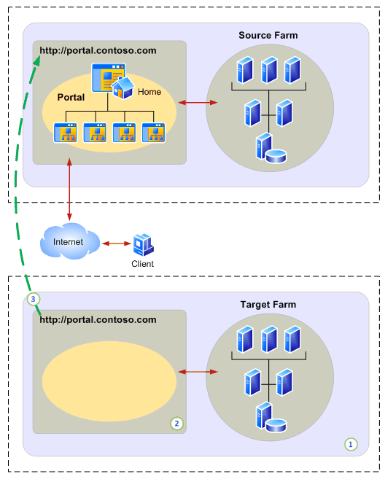
- Change the network name resolution to point the AAM redirection URL to the source Web application.
- Modify the source Web application to use the AAM redirection URL as the primary URL.
- Change the network name resolution to point the source URL to the target Web application.
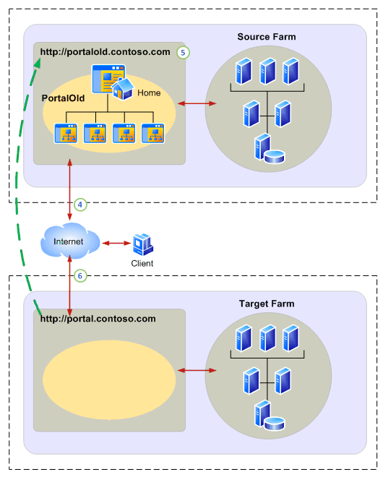
- Upgrade the content databases from the source farm by using the database attach upgrade method, starting with the content database that contains the root site collection first.
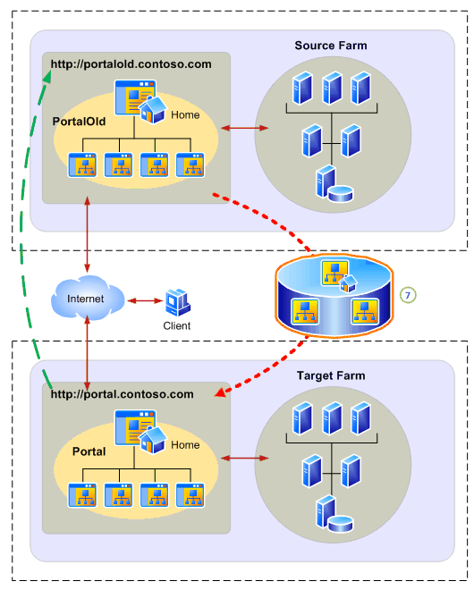
Note: Original databases can be left in a read-only state during upgrade to provide a fallback location to use to compare with upgraded content, or to revert to in case the upgrade fails.

Configuration Process

Prepare the Previous Version Farm
Ensure that the existing Microsoft® Office SharePoint® Server 2007 or Windows® SharePoint Services 3.0 farm has been upgraded successfully to at least Service Pack 2 (SP2) and the April 2009 Cumulative Update (CU) for Office SharePoint Server 2007 or Windows SharePoint Services 3.0. Although SP2 is the minimum requirement for upgrade to SharePoint 2010 Products, the April CU adds some additional benefits around URL link fix-up and improvements to the mergecontentdbs operation, which will prove to be useful later in this process.

Set Up the New Version Farm
If you want to preserve existing service data and settings from the Office SharePoint Server 2007 or Windows SharePoint Services 3.0 farm, follow these steps:
- On separate hardware, build a new Office SharePoint Server 2007 or Windows SharePoint Services 3.0 farm in parallel to the source Office SharePoint Server 2007 or Windows SharePoint Services 3.0 farm, but do not create a Web application for content databases. This will become the target SharePoint 2010 Products farm.
- Back up existing farm services from the source farm.
- Restore farm services to the target farm.
- Configure farm services as necessary on the target farm, and confirm that they operate properly.
- Upgrade the target farm to SharePoint 2010 Products.
- Confirm that the services were upgraded correctly, and reconfigure them as necessary to match the SharePoint 2010 Products configuration you have planned.
If you do not want to preserve existing services data and settings from the Office SharePoint Server 2007 or Windows SharePoint Services 3.0 farm, follow these steps:
- On separate hardware, build an entirely new SharePoint 2010 Products target farm in parallel to the source Office SharePoint Server 2007 or Windows SharePoint Services 3.0 farm.
- Set up services as necessary, and confirm that they operate properly.

Determine URL Settings and Prepare DNS for Redirection
- On the source Office SharePoint Server 2007 or Windows SharePoint Services 3.0 farm, determine the original URL — that is, the current alternate access mapping (AAM) URL settings for the Web application you plan to set up as the target of AAM redirection. The list of current AAM settings for a Web application can be found by using the Stsadm enumalternatedomains operation with the following syntax:
STSADM.EXE -o enumalternatedomains -url http://originalURL
For more information about this operation, see Enumalternatedomains: Stsadm operation (Office SharePoint Server) (http://technet.microsoft.com/en-us/library/cc263292(Office.12).aspx) or Enumalternatedomains: Stsadm operation (Windows SharePoint Services) (http://technet.microsoft.com/en-us/library/cc288303(Office.12).aspx).
- For each zone that appears in the XML report generated by the enumalternatedomains operation, make a note of each Mapped URL value (which represents the public URL in AAM) and all of the Incoming URL values. You can use the following table to record these URLs, but for now leave the Redirection URL column blank:

Zone | Incoming URL | Public URL / Mapped URL | Incoming IP | Redirection URL | Redirection IP
Default
Intranet
Internet
Extranet
Custom

- Determine the current DNS lookup values for each Incoming URL by using the NSLookup command, and note their IP addresses in the above table in the Redirection IP column.
- Determine a new redirection host name URL for each AAM zone on the Office SharePoint Server 2007 or Windows SharePoint Services 3.0 farm you intend to use as a redirection target for content requests.
- You now need to add a new entry to the DNS server to allow access for a new URL for each zone you intend to allow redirection for. From the table in step 2, assign the new redirection URL to a new DNS entry on the DNS server pointing to the existing matching Redirection IP address from the above table.
- Acquire new IP addresses for each Web application zone that this farm will be redirecting for, and mark them down in the Incoming IP column in the above table.
- If you are using a software or hardware load balancer, add load-balancer settings to point the Redirection URL values to the source Office SharePoint Server 2007 or Windows SharePoint Services 3.0 farm Web application.

Set Up the Parallel Web Application
- On the target farm, build a new Web application to support the original URL that is on source Office SharePoint Server 2007 or Windows SharePoint Services 3.0 farm by using data from the table you filled out in the preceding procedure. Use the same original URL for the same zone to reduce complexity in troubleshooting. Ensure that the same security settings are configured on the Web application, including anonymous access settings and Forms or Windows authentication methods. If the original Web application on Office SharePoint Server 2007 or Windows SharePoint Services 3.0 was extended to multiple zones, you have the option to extend the SharePoint 2010 Products Web application to the matching set of zones so that redirection can occur correctly for all the URLs.
- Set up the target farm Web application AAM redirection settings to redirect failed site collection lookups to the Office SharePoint Server 2007 or Windows SharePoint Services 3.0 Web application, by using data from the above table. The AAM redirection must be set for the Web application zone by using the Stsadm addzoneurl operation with the following syntax:
STSADM.EXE -o addzoneurl -url http://originalURL -urlzone ZoneName -zonemappedurl http://originalURL -redirectionurl http://redirectionURL
For more information about this operation, see Addzoneurl: Stsadm operation (Office SharePoint Server) (http://technet.microsoft.com/en-us/library/cc261980(Office.12).aspx) or Addzoneurl: Stsadm operation (Windows SharePoint Services) (http://technet.microsoft.com/en-us/library/cc288035(Office.12).aspx).
- Verify that the redirection URLs have been successfully applied to AAM by using the Stsadm enumalternatedomains operation with the following syntax:
STSADM.EXE -o enumalternatedomains -url http://originalURL
For more information about this operation, see Enumalternatedomains: Stsadm operation (Office SharePoint Server) (http://technet.microsoft.com/en-us/library/cc263292(Office.12).aspx) or Enumalternatedomains: Stsadm operation (Windows SharePoint Services) (http://technet.microsoft.com/en-us/library/cc288303(Office.12).aspx).
- Configure the same managed paths on the new SharePoint 2010 Products Web application so that sites can use the same managed paths after upgrade. Refer to the Office SharePoint Server 2007 or Windows SharePoint Services 3.0 managed paths list for the data to use on the SharePoint 2010 Products Web application.
- Install any required customizations on the target SharePoint 2010 Products farm, and ensure that they are appropriately registered to work with the new Web application.
- While you have the redirection system set up, disable self-service site creation on the new SharePoint 2010 Products Web application. If you do not disable this feature, users might create new site collections that conflict with the URLs of non-upgraded site collections in the source Office SharePoint Server 2007 or Windows SharePoint Services 3.0 farm.

Test the Redirect Before Continuing
- As a test measure, temporarily set up the hosts file (“%windir%/system32/drivers/etc/hosts”) on a client computer so that the original URL is sent to the IP address of the new Web application in the SharePoint 2010 Products farm that will host the original URL.
- After this is complete, you can verify that the redirection is working correctly by opening a Web browser on the computer on which you set up the modified hosts file and attempting to access a URL you have access to from the original URL. The following sequence should occur: The target SharePoint 2010 Products farm should attempt to process the request, and then the browser should get an HTTP 302 client-side redirect that immediately redirects the browser to the redirection URL while preserving the appropriate path to the requested content.
- Remove the hosts file entries you added in step 1. They can interfere with future testing.

Change Over to the Redirection System
- Use the Office SharePoint Server 2007 or Windows SharePoint Services 3.0 Web application URL change process on the source Web application to change to a temporary URL. For detailed instructions about this process, see Update a Web application URL and IIS bindings (Windows SharePoint Services) (http://go.microsoft.com/fwlink/?LinkId=169506).
- You now need to modify the entries on the DNS server to map the source Office SharePoint Server 2007 or Windows SharePoint Services 3.0 farm incoming URLs to the appropriate target SharePoint 2010 Products farm incoming URL IP address for each zone you intend to redirect. Using data from the above table, modify the DNS entries for the original URL to point to the matching incoming IP address on the DNS server.
- If you are using a software or hardware load balancer, change the load-balancer settings to point the original Web application incoming URLs to the target SharePoint 2010 Products farm Web application.
- Verify that requests sent to site collections under the original URL are now first sent to the target SharePoint 2010 Products farm and then redirected to the redirection URL hosted by the source Office SharePoint Server 2007 or Windows SharePoint Services 3.0 farm.
- On the source Office SharePoint Server 2007 or Windows SharePoint Services 3.0 farm, some link fix-up may be required, as in the case of InfoPath form templates. Use the appropriate downloadable tool to accomplish this on the source Web application for any content that will not be immediately upgraded.

Test the Redirect Before Continuing
On a client computer or the server that hosts the SharePoint 2010 Products target farm, attempt to access content by using the original URL. The target SharePoint 2010 Products farm should first attempt to process the request, and then the browser should get an HTTP 302 client-side redirect that immediately redirects the browser to the redirection URL while preserving the appropriate path to the requested content.

Perform the Upgrade Process
Now that you have a working redirect system, you can continue to the database attach upgrade process.

Important: The root site collection for the Web application must be upgraded before any other site collections. Be sure that the content database that contains the root site collection is the first to be upgraded.

Upgrade Process
The upgrade process is based on content database attach upgrades between Microsoft® Office SharePoint® Server 2007 or Windows® SharePoint Services 3.0 and SharePoint 2010 Product farms. As part of this process, you can only roll back content for individual site collections if the original Office SharePoint Server 2007 or Windows SharePoint Services 3.0 content databases still exist, so be sure to back up your databases before you proceed.

Note: The root site collection must be upgraded before any other site collections (and it might be in its own database). The reason you need to upgrade the root site collection first is to ensure that any references to root-level resources, such as _vti_bin or _layouts, will not be redirected; if these references are redirected, the resources will fail to render upgraded content correctly. This same limitation existed in gradual upgrade to Office SharePoint Server 2007 or Windows SharePoint Services 3.0.

To upgrade content databases while retaining the possibility of immediately rolling them back for site collections
- Make a backup copy of the Office SharePoint Server 2007 or Windows SharePoint Services 3.0 content database.
- Mark the original content database as read-only to prevent any content from being updated to the wrong version.
- Restore the copy of the database with a new name to the same or a different instance of SQL Server.
- Attach the restored and renamed database to the SharePoint 2010 Products Web application, initiating the upgrade.
- Verify that upgrade was completed successfully.

Note: If upgrade fails in an unrecoverable state, you can set the Office SharePoint Server 2007 or Windows SharePoint Services 3.0 copy of the database back to read/write so that users can access the site again.

To upgrade content databases while removing the old version copy (no easy rollback)
- Make a backup copy of the Office SharePoint Server 2007 or Windows SharePoint Services 3.0 content database.
Note: A SQL backup allows the possibility of rolling back should upgrade fail in an unrecoverable state.
- Detach the content database from the Office SharePoint Server 2007 or Windows SharePoint Services 3.0 farm.
- Attach the content database to the SharePoint 2010 Products Web application, initiating the upgrade.
- Verify that upgrade was completed successfully.

If a single site collection must be upgraded separately
- Move the site collection to a new separate content database in Office SharePoint Server 2007 or Windows SharePoint Services 3.0 by using the Stsadm mergecontentdbs operation.
For more information about this operation, see Mergecontentdbs: Stsadm operation (Office SharePoint Server) (http://technet.microsoft.com/en-us/library/cc262923(Office.12).aspx) or Mergecontentdbs: Stsadm operation (Windows SharePoint Services) (http://technet.microsoft.com/en-us/library/cc288557(Office.12).aspx).
- After the site collection has been moved, you can upgrade the database while either removing or retaining the Office SharePoint Server 2007 or Windows SharePoint Services 3.0 copy, as indicated previously.
If a single site collection must be rolled back
- If the Office SharePoint Server 2007 or Windows SharePoint Services 3.0 database that contains the site collection is still attached to the Office SharePoint Server 2007 or Windows SharePoint Services 3.0 farm, delete the site collection from the SharePoint 2010 Products farm.
- If the Office SharePoint Server 2007 or Windows SharePoint Services 3.0 database that contains the site collection is no longer attached to the Office SharePoint Server 2007 or Windows SharePoint Services 3.0 farm, first restore the appropriate Office SharePoint Server 2007 or Windows SharePoint Services 3.0 content database and attach it to the Office SharePoint Server 2007 or Windows SharePoint Services 3.0 Web application. Then, you can delete the site collection from the SharePoint 2010 Products farm to allow the rollback to Office SharePoint Server 2007 or Windows SharePoint Services 3.0.
- The Office SharePoint Server 2007 or Windows SharePoint Services 3.0 copy of the database will have to be set to read/write if it was set as read-only; if it is not, users will be unable to add or modify any content. Note that any site collections that are not explicitly set to read-only will become available for adding or modifying content, even if a copy of the content database exists in the SharePoint 2010 Products farm. To avoid this, you can explicitly set all remaining upgraded site collections to read-only in that Office SharePoint Server 2007 or Windows SharePoint Services 3.0 content database.

Upgrade Outage Considerations
If a user attempts to access a site collection in a database that is in the process of being upgraded, the user will see the following message: “Server error: http://go.microsoft.com/fwlink?linkID-96177”. To prevent users from seeing this error and to reduce perceived downtime, consider using a temporary upgrade farm to perform the longer-running upgrade action while the original content database is in a read-only state. For more information, see the description of the read-only databases upgrade approach in Upgrade process overview (SharePoint Server 2010) (http://go.microsoft.com/fwlink/?LinkId=169507) and Upgrade process overview (SharePoint Foundation 2010) (http://go.microsoft.com/fwlink/?LinkId=169509).
The source database can be set to read-only before the upgrade is started; a copy of the database can be attached and upgraded on a separate, new version, temporary upgrade farm; and then the database copy can finally be detached from the temporary upgrade farm and attached to the new version production farm. This results in a much shorter window of time in which users are likely to encounter this error.

Old Version Command Reference
The following tables describe the parameters for the Stsadm addzoneurl and enumalternatedomains operations in Office SharePoint Server 2007 and Windows SharePoint Services version 3.0.

STSADM.EXE -o addzoneurl {-url <URL name> | -resourcename <non-Web application resource name>} -urlzone <default | internet | intranet | extranet | custom> -zonemappedurl <http://public.url>

Parameter | Description
URL | URL of the Web application. This parameter should be an existing AAM URL that is assigned to a Web application so that Stsadm can determine which Web application you are targeting. The URL can be a public URL or an internal URL from any zone associated with the Web application you want.
ResourceName | Name of a resource on which to adjust the AAM setting.  This parameter is equivalent to the External Resource Mapping user interface setting that is located on the Create External Resource Mapping page of the SharePoint Central Administration Web site.
URLZone | Specifies which of the five zones you want to associate with the public URL.
ZoneMappedURL | Base URL used in hyperlinks on Web pages or e-mail messages going from the Web server to the reverse proxy server or the client computer. This is the URL that can be reached by the end user, and it ensures that the user sees the correct URL when the content is returned from the server to the client computer.  The public URL and one incoming URL for the zone will be set to this value.

STSADM.EXE -o enumalternatedomains [-url <protocol://existing.WebApplication.URLdomain>]

Parameter | Description
URL | If present, this parameter will output the AAM information only for the specified incoming URL.
ResourceName | If present, this parameter will output the AAM information only for the specified external resource.

Output
<AlternateDomains>
<Collection Count=”4” Name=”Default Web Site”>
<AlternateDomain>
<IncomingUrl>http://spfarm</IncomingUrl>
<UrlZone>Default</UrlZone>
<MappedUrl>http://spfarm</MappedUrl>
</AlternateDomain>
<AlternateDomain>
<IncomingUrl>https://spfarm.company.com</IncomingUrl>
<UrlZone>Internet</UrlZone>
<MappedUrl>https://spfarm.company.com</MappedUrl>
</AlternateDomain>
<AlternateDomain>
<IncomingUrl>http://spfarmsecure</IncomingUrl>
<UrlZone>Internet</UrlZone>
<MappedUrl>https://spfarm.company.com</MappedUrl>
</AlternateDomain>
<AlternateDomain>
<IncomingUrl>http:// spserver:6001</IncomingUrl>
<UrlZone>Custom</UrlZone>
<MappedUrl>http://spserver:6001 </MappedUrl>
</AlternateDomain>
</Collection>
</AlternateDomains>

The following table describes the sections that appear in the output for the enumalternatedomains operation.

Name | Description
AlternateDomains | This tag is the root tag for any successful call to this command. This tag may optionally specify the count of AAM entries and the name of the resource if a URL or ResourceName parameter was specified.
Collection | This tag contains the name of the Web application, count of AAM entries, and the zones that have been specified on the Web application. This tag is only present if no URL or ResourceName parameters were specified.
AlternateDomain | This tag contains the list of zone information and URLs for a zone.
IncomingUrl | This tag contains the incoming URL for the zone.
UrlZone | This tag contains the zone that this alternate domain entry is for. This tag will only contain the following values: Default, Internet, Intranet, Extranet, Custom
MappedUrl | This tag contains the public/response URL for the zone.

New Version Command Reference
The following tables describe the parameters for the Stsadm addzoneurl and enumalternatedomains operations in SharePoint® 2010 Products.
STSADM.EXE -o addzoneurl {-url <URL name> | -resourcename <non-Web application resource name>} -urlzone <default | internet | intranet | extranet | custom> -zonemappedurl <http://public.url> [-redirectionurl <http://redirect.url>]

Parameter | Description
URL | URL of the Web application. This parameter should be an existing AAM URL that is assigned to a Web application so that Stsadm can determine which Web application you are targeting. The URL can be a public URL or an internal URL from any zone associated with the Web application you want.
ResourceName | Name of a resource on which to adjust the AAM setting. This parameter is equivalent to the External Resource Mapping user interface setting that is located on the Create External Resource Mapping page of the SharePoint Central Administration Web site.
URLZone | Specifies which of the five zones you want to associate with the public URL.
ZoneMappedURL | Base URL used in hyperlinks on Web pages or e-mail messages going from the Web server to the reverse proxy server or the client computer. This is the URL that can be reached by the end user, which ensures that the user sees the correct URL when the content is returned from the server to the client.  The public URL and one incoming URL for the zone will be set to this value.
RedirectionURL | When specified, this parameter indicates the redirection URL that should be set up to redirect from the client computer to the old version Web application. This command should only succeed if the Web application is currently set up as a target for gradual upgrade. If no value is specified, the redirection URL will be removed.

STSADM.EXE -o enumalternatedomains [-url <protocol://existing.WebApplication.URLdomain> | -resourcename <non-Web application resource name>]

Parameter | Description
URL | If present, this parameter will output the AAM information only for the specified incoming URL.
ResourceName | If present, this parameter will output the AAM information only for the specified external resource.

Output
<AlternateDomains>
<Collection Count=”4” Name=”Default Web Site_Pair”>
<AlternateDomain>
<IncomingUrl>http://spfarm</IncomingUrl>
<UrlZone>Default</UrlZone>
<MappedUrl>http://spfarm</MappedUrl>
<RedirectUrl>http://spfarmoldver</RedirectUrl>
</AlternateDomain>
<AlternateDomain>
<IncomingUrl>https://spfarm.company.com</IncomingUrl>
<UrlZone>Internet</UrlZone>
<MappedUrl>https://spfarm.company.com</MappedUrl>
<RedirectUrl>https://spfarmoldver.company.com</RedirectUrl>
</AlternateDomain>
<AlternateDomain>
<IncomingUrl>http://spfarmsecure</IncomingUrl>
<UrlZone>Internet</UrlZone>
<MappedUrl>https://spfarm.company.com</MappedUrl>
<RedirectUrl>https://spfarmoldver.company.com</RedirectUrl>
</AlternateDomain>
<AlternateDomain>
<IncomingUrl>http:// spserver:6001</IncomingUrl>
<UrlZone>Custom</UrlZone>
<MappedUrl>http://spserver:6001 </MappedUrl>
<RedirectUrl/>
</AlternateDomain>
</Collection>
</AlternateDomains>
The following table describes the sections that appear in the output for the enumalternatedomains operation.

Name | Description
AlternateDomains | This tag is the root tag for any successful call to this command. This tag may optionally specify the count of AAM entries and the name of the resource if a URL or ResourceName parameter was specified.
Collection | This tag contains the name of the Web application, count of AAM entries, and the zones that have been specified on the Web application. This tag is only present if no URL or ResourceName parameters were specified.
AlternateDomain | This tag contains the list of zone information and URLs for a zone.
IncomingUrl | This tag contains the incoming URL for the zone.
UrlZone | This tag contains the zone that this alternate domain entry is for. This tag will only contain the following values: Default, Internet, Intranet, Extranet, Custom
MappedUrl | This tag contains the public/response URL for the zone.
RedirectUrl | This tag contains the public/response redirection URL for the zone. This tag will only contain a value if the zone has been set up with a redirection path.

