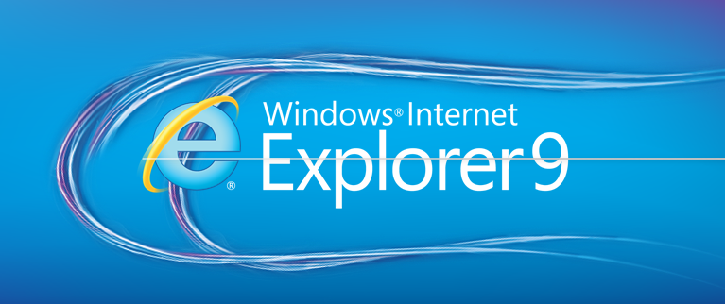

Windows Internet Explorer 9
Fact Sheet
March 2011

What’s new in Windows Internet Explorer 9?
Customers upgrading from Internet Explorer 8 will notice performance improvements, a safer experience that puts the focus on their favorite websites and tweaks to the user interface — changes that help make your websites shine.

There are three core pillars that represent how we reimagined the role of the browser with Internet Explorer 9 to deliver an experience that makes your web feel as native as the applications running on your PC:
- Fast: Internet Explorer 9 is all-around fast. Part of reimagining the role of the browser to deliver immersive, compelling web experiences is rethinking the concept of fast. Today, fast is too often narrowly defined as page load time. Tomorrow, a browser will not be able to call itself fast unless it lets people interact with graphically rich sites and applications with lightning speed. Fully hardware-accelerated graphics, text, video, and audio through Windows means that the same markup not only works across the web, but runs faster and delivers a richer experience. Designed to take full advantage of the power of your computer’s hardware through Windows, Internet Explorer 9 delivers dynamic experiences that are as fast and responsive as native applications installed on your computer.
- Clean: Internet Explorer 9 puts the focus on the web sites you love, with a clean experience for your web that meets you where you are. With Internet Explorer 9 and Windows, we rethought the role of the browser and how people interact with websites and web applications. While other browsers focus on the browser itself, Internet Explorer 9 is site-centric, as opposed to browser-centric. You have the websites you love with a clean look that makes your websites shine.
- Trusted: Internet Explorer 9 helps people feel confident and in control. The more that the web becomes part of our everyday lives, the more complex that the issues of online trust and browser trust become. When done correctly, creating a trustworthy browser helps customers feel connected to the web, not distracted by concerns about reliability, privacy, or safety. Internet Explorer 9 is the trusted way to access the web because it has a robust set of built-in security, privacy, and reliability technologies that can help keep you safer and your browsing experience virtually uninterrupted.

Enjoy an all-around fast experience with Windows Internet Explorer 9
Designed to take full advantage of your Windows-based computer's hardware, Internet Explorer 9 enables developers to build graphically rich and immersive Web experiences that are as fast and responsive as applications installed on your computer, making for a better consumer experience. These new features make the Web all-around fast with Internet Explorer 9 on Windows.
- Full hardware-acceleration. Hardware-accelerated text, video and graphics mean that your websites perform like applications installed directly on your Windows-based computer.
- New JavaScript engine. Chakra, the recently optimized JavaScript engine, interprets, compiles and executes code in parallel by taking advantage of multiple CPU cores.

Clean site-centric design makes sites shine and integrates with Windows 7
With a clean look and an increased viewing area, Windows Internet Explorer 9 puts the focus on the things you love and makes your websites shine. Your favorite sites are taken out of the browser box, with seamless Windows 7 integration.
- Clean browser user interface. In Internet Explorer 9, the simplified user interface and site-centric user experience put the focus on the content of each website. This means less screen real estate is taken up by the browser, letting people browse and experience more of what websites have to offer.
- Pinned Sites. With Pinned Sites, your favorite websites can be accessed directly from the Windows 7 taskbar without having to first open the browser. You can pin sites to the taskbar by dragging the tab or the icon to the left of the URL to the taskbar, then easily find and launch those sites you access most often — just like native applications on the PC. When a pinned site is launched from the taskbar, the browser frame and navigational controls integrate the site’s icon and primary color, emphasizing the site and providing an even more site-focused experience.
- Jump Lists. With Jump Lists, you have a quick and easy way to get to a common website task without having to launch the browser first. For Pinned Sites where developers have created Jump Lists capabilities, you can quickly create a new e-mail message, check your inbox, change your music station, accept a friend invite or see breaking news.
- Windows Aero Snap for your websites. You often need to use more than one website or page to accomplish a task. In Internet Explorer 9, Microsoft has reduced the frame, giving more room than competitors to let your sites shine. In addition, tearing off a tab by dragging it away from the browser, and using Windows Aero Snap to position the content, is a great way to show two sites or pages side by side.
- One Box. One Box gives people a single place to start whether they want to navigate to a specific site or search for a site. One Box in Internet Explorer 9 incorporates search functionality into the Address Bar. With One Box, you can navigate to a site, search for a site, switch between search providers, or access browsing history, Favorites, or suggestions from search providers.
- One Box Top Result. Another feature that speeds browsing is Address Bar Top Result. Address Bar Top Result helps you remember the Web address for common websites by taking you directly to the top results of your search provider without first displaying the search results page.

Feel the confidence and trust you are in control with Windows Internet Explorer 9
Internet Explorer 9 is a trusted way to surf the Web because it has a robust set of built-in security, privacy and reliability technologies that help keep you safer and your browsing experience virtually uninterrupted. These new features help provide the trust you need to feel safer online.
- Tracking Protection. Some content on websites can be used to track your activity as you browse the Web. Tracking Protection allows you to limit the browser's communication with certain websites — determined by a Tracking Protection List — to help keep your information private. Anyone can create Tracking Protection Lists, and some are available today.
- ActiveX Filtering. ActiveX is a technology that allows Web developers to create interactive content on their sites, but it can also pose a security risk. Internet Explorer 9 allows you to block ActiveX Controls for all sites, and then turn them back on for only the sites that you trust with the new ActiveX Filtering option.
- Hang recovery. In Internet Explorer 9, this feature isolates the impact of a hung tab to the individual tab, so that other tabs and the overall browser continue to operate. When a website hangs because of a long-running script or other operation, it causes your browser to become nonresponsive. Hang recovery in Internet Explorer 9 means you can continue browsing on other tabs. This new feature complements tab isolation and automatic crash recovery, which also helps keep you browsing and prevent the loss of information.
- Compatibility View. You can feel good knowing that your favorite websites will run in the newest version of Internet Explorer. If Internet Explorer 9 detects a website that has not specified its desired display mode, the Compatibility View button appears next to the Refresh button on the Address Bar. Pressing the Compatibility View button causes Internet Explorer 9 to switch to a legacy document mode. The state of the button is saved for that Web page, so there is no need to press it again when you return to the same page at a later time.
- Automatic updates. Getting the latest browser updates helps keep you protected over time. You can choose to have important updates installed automatically, once they are made available. Automatically installed updates can include security updates, critical updates, definition updates, update rollups and service packs through Windows Update.
- Group Policy support. For IT professionals, Internet Explorer 9 continues to provide excellent Group Policy support. With nearly 1,500 Group Policy settings, including new settings to support Windows Internet Explorer 9 features, IT professionals have the control they need to manage Internet Explorer installations after deployment.

Write interoperable markup with HTML5 and Windows Internet Explorer 9
Extensive support for HTML5, Scalable Vector Graphics (SVG), Cascading Style Sheets Level 3 (CSS3), ECMAScript 5 and DOM provides a new set of capabilities that will help enable developers write one set of markup language and know that it will work and look the same in all modern browsers. Internet Explorer 9 was designed with support for industry standards built in to help ensure that the same markup language works the same across browsers.

For more information:
http://www.microsoft.com/presspass/presskits/internetexplorer/
http://www.beautyoftheweb.com/

IE9 free download site:
http://windows.microsoft.pt/IE9

