Create and manage a SharePoint blog

You can create a SharePoint blog to quickly share ideas and information in an informal way.

HOW DO I CREATE A BLOG?
- Open your SharePoint site.
- On the Settings menu, click Site contents.
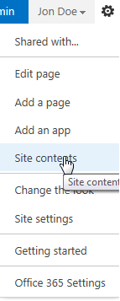
- Click new subsite.
- Enter a title, description, and URL. Under Select a template, select Blog.
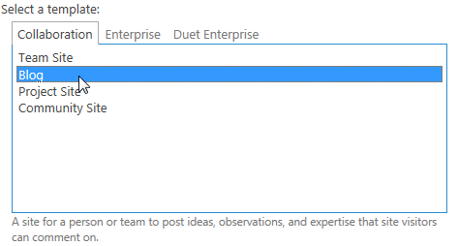
- Click OK.
CREATE A POST
- On the home page of the SharePoint blog, under Blog tools, click Create a post.
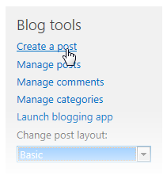
- Enter a title, and an optional description.
- In the Category section, select as many categories as yu want the post to be associated to, and click Add.
- Enter a publish date.
- Click Publish
ADD CATEGORIES
- On the home page of the SharePoint blog, under Blog tools, click Manage categories.
- Click new item.
- Type a category name, and click Save.
BREAK INHERITANCE FROM THE PARENT SITE FOR A BLOG
- Open your SharePoint blog.
- On the Settings menu, click Site settings.
- Under Users and Permissions, click Site permissions.
- On the Permissions tab, click Stop Inheriting Permissions.
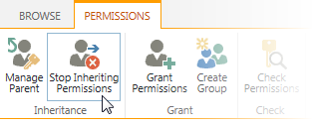
- Click OK.

CREATE UNIQUE PERMISSIONS FOR LISTS AND LIBRARIES IN A BLOG
- Open the SharePoint blog.
- On the Settings menu, click Site contents.
- Click on the ellipsis next to Posts and then click Settings.
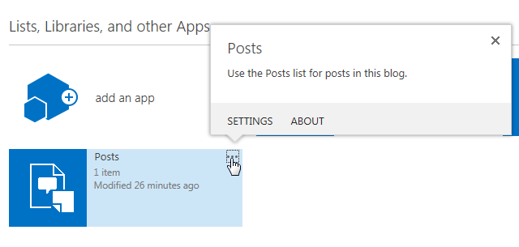
- On the Settings page, click Permissions for this list.
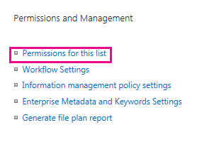
- On the Permissions tab, click Stop Inheriting Permissions.
- Click OK.
- You can now add users and groups, and give them specific permissions. To do that, click Grant Permissions, on the ribbon.
- Enter a user or group name, or email address.
- Click Show Options, and then select a permission level from the dropdown.Then click Share.

CHANGE A BLOG POST LAYOUT
On the home page of your SharePoint blog, under Blog Tools, select a post layout.
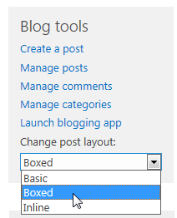

SEE ALSO:
- Introduction: Control user access with permissions
http://office.microsoft.com/en-us/support/introduction-control-user-access-with-permissions-HA102771919.aspx
- What is permissions inheritance?
http://office.microsoft.com/en-us/office365-sharepoint-online-enterprise-help/what-is-permissions-inheritance-HA102772762.aspx

