DSC Contributions Toward Achieving Select UN Sustainable Development Goals
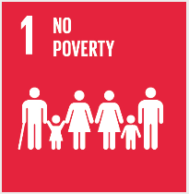 | - Ensure suppliers cover workers’ social insurance and contractual and legal requirements for payment of compensation  - Require Tier 1 suppliers to provide workers with career development and related opportunities
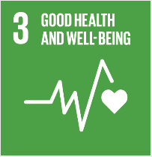 | - Require proper sanitation and healthful living and canteen conditions for workers  - Ensure Tier 1 factories have appropriate onsite medical services  - Train and require factories and contracted suppliers to implement effective Occupational Health and Safety programs  - Design and manufacture products that are safe for their intended use  - Recycle Microsoft consumer and directly used devices responsibly through voluntary and mandatory programs  - Support responsible health and safety in the global extractives industry
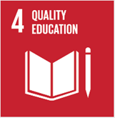 | - Increase access to digital education through implementation of factory worker YouthSpark Computer Training Pilot  - Support factory career development and training programs  - Require computer access in Tier 1 factories, including wireless infrastructure  - Require library/literature access at factories
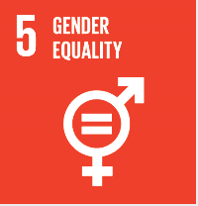 | - Implement in Tier 1 factories an independent Grievance Hotline for reporting of issues or abuses  - Require factories to implement nondiscrimination policies  - Audit for fair payment of wages and enforce corrective action  - Provide training to workers regarding women’s health
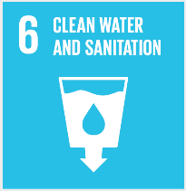 | - Ensure appropriate testing and availability of safe drinking water at factories  - Increase water use efficiency of factories and Tier 1 suppliers and implement water balancing  - Protect water use ecosystems through wastewater treatment, spill prevention, and chemical management of storing, handling, and disposal.  - Support heightened environmental standards related to water usage for the extractives industry, including process improvements
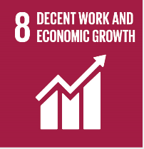 | - Implement training of factory and supplier workers for career escalation and promote digital learning and access to Microsoft technology classes  - Train line leaders to exercise fair and equitable treatment of workers and ban penalties and other punitive measures  - Improve resource efficiency at owned and contracted supplier factories while maintaining and improving working and living conditions
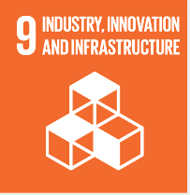 | - Promote environmentally sound and effective safety engineering infrastructures at owned and supplier factories such as wastewater treatment systems, combustive dust management, and emissions controls  - Optimize distribution and logistics management to reduce energy and materials usage  - Establish the Audit Management System through Azure and employ smarter analytics and dashboards through Power BI.  - Track and analyze factory and supplier chemical usage through a cloud-based solution using Microsoft platforms
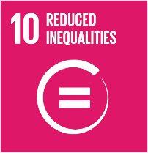 | - Require wireless access and computer rooms/Internet at Tier 1 factories  - Empower the legal right of inclusion of factories workers in factory governance through an organized workforce and require supplier factories to implement process for management/worker dialogs
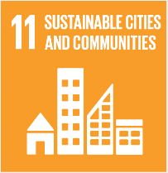 | - Build and promote adoption of environmentally sound technologies and processes in factories and contracted suppliers  - Promote wireless Internet access for factory workers at contracted (require for Tier 1 factories) as well as connected access through computer terminals.
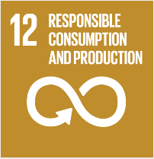 | - Implement an ISO 14001 certified manufacturing and supply chain and require all contracted suppliers to run an effective Environmental Management System  - Proactively reduce materials used for devices and packaging  - Design for recyclability and product stewardship  - Incorporate recycled and sustainable content into devices and packaging and implement recycling during production and at end of life  - Qualify all eligible devices for EPEAT and other green procurement programs  - Implement environmentally sound management of chemicals and all wastes throughout their life cycle through use of Microsoft platform partner software suite
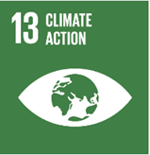 | - Require substitution for and ban use of Ozone Depleting Chemicals and assess hydrofluorocarbon (HFC) usage to prepare for minimizing related emissions and consumption  - Ensure all products meet or exceed voluntary energy efficiency standards including ENERGY STAR  - Minimize device energy consumption through the Windows platform  - Minimize use of materials and report greenhouse gas (GHG) emissions, and require Tier 1 suppliers to do the same pursuant to the CDP (Carbon Disclosure Project)
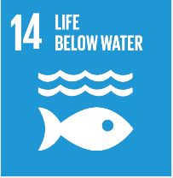 | - Evaluate factory drain lines and monitor for and require corrective actions to ensure proper wastewater treatment and reuse of graywater to eliminate pollution of waterways by contract suppliers  - Build capabilities of contract suppliers to implement protective pipeline/storage tank design and chemical spill prevention, control, and disposal methods to prevent drainage of hazardous substances into storm drains
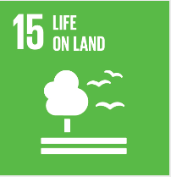 | - Use recycled paperboard materials and/or virgin paper from sustainable forests  - Ban the use any packaging materials originating from old growth forests  - Ban landfilling by Microsoft of devices and restrict out of country recycling by contracted recyclers
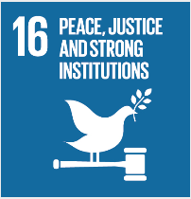 | - Incorporate and implement Supplier Anti-Trafficking measures in the Microsoft Supplier Code of Conduct, auditing, supplier programs and management systems, and increase reporting transparency  - Implement anticorruption measures through contracted supplier management and monitoring
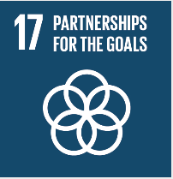 | - Promote sustainability best practice sharing and collaboration with suppliers, the electronics sector, cross-industry groups, and NGOs  - Initiate additional software donations of Microsoft products to enhance NGO capability, capacity, and efficacy.  - Partner with stakeholders of the Windows and Devices Group to support digital technology enablement for reaching the Sustainable Development Goals

