Engineering, Consulting, and Construction Firm Tackles Multi-Billion Dollar Pipeline
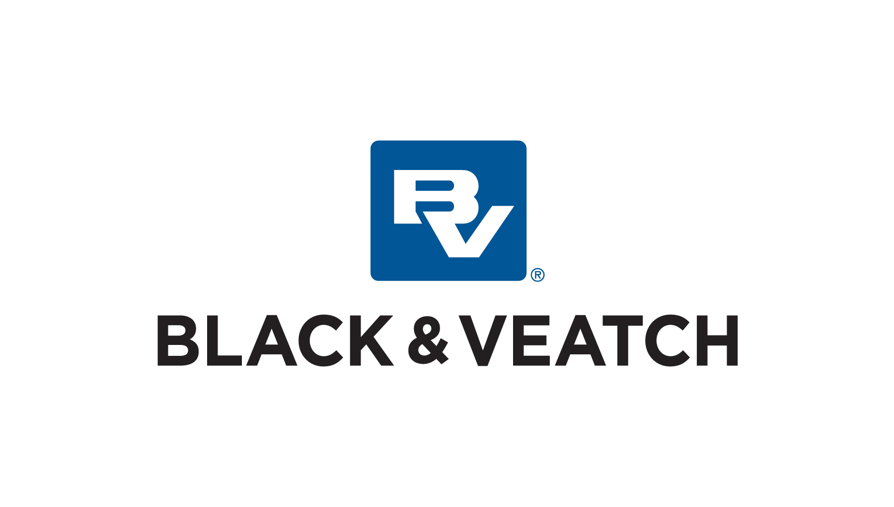
Microsoft Dynamics Results Case Study
Founded in 1915, Black & Veatch is an employee-owned, global leader in engineering, procurement, and construction. With deep expertise in the energy, water, telecommunications, and government sectors, the company works with clients in over 100 countries and reported annual revenue more than US$3.3 billion in 2012.

Results
- Better manage sales pipeline
- Standardize business processes
- Enable company growth

Industry
Architecture and Engineering Services

Country or Region
United States

Customer Size
Over 10,000 professionals

Number of Users
1,200 professionals

Connect with Black & Veatch
www.bv.com

“The ability to access Microsoft Dynamics CRM both through Microsoft Outlook and over the web is a big benefit for us. For a company operating worldwide, it meant achieving the anywhere, anytime access that we needed.”

Tim Thorpe, Director of Digital Content, Global Marketing & Communications, Black & Veatch
In the engineering, procurement, and construction (EPC) space, projects can run into the hundreds of millions—sometimes billions—of dollars. For Black & Veatch, an EPC firm based out of Overland Park, Kansas, sales pipeline management is critical. With project lead times measured in years, and project estimates and proposals running into the millions of dollars (US) to produce, effective pipeline management is an important means by which the company plans for, and secures, its profitability and its future.
Rated in the top quartile of performance with its peer group, the company has delivered double-digit percentage growth and has a three-year Compound Annual Growth Rate (CAGR) of more than 60 percent. As the company grew into a global player and expanded its operations and workforce considerably, its need for a more robust, scalable, and customizable customer relationship management (CRM) solution kept pace.
“We had a homegrown CRM system that worked when we had a user base of around 300,” says Fredrik Winterlind, Vice President, Global Marketing & Communications for Black & Veatch. “But as we transformed further into a large, global enterprise, we knew we had outgrown it. We needed a system with a full range of features that would also scale and be flexible to the unique needs of the industry that we’re in.”

Choosing Microsoft Dynamics CRM
Looking for a system that would support the needs of a global sales organization in the EPC space, Black & Veatch reviewed multiple CRM products. They chose Microsoft Dynamics CRM based on its ability to meet the current and future business process needs of the growing company.
Black & Veatch deployed Microsoft Dynamics CRM on-premises, so it could customize the system to meet the company’s diverse business needs. ”The solution has proven to be a particularly good fit for a distributed, global enterprise,” Thorpe says. “The ability to access Microsoft Dynamics CRM both through Microsoft Outlook and over the web is a big benefit for us. For a company operating worldwide, it provides us with the anywhere, anytime access that we need.”

Beyond Sales
Black & Veatch’s use of Microsoft Dynamics CRM spans several major business areas:
- Business Processes. Black & Veatch treats Microsoft Dynamics CRM as the single point of entry at which all projects begin. “Project proposals can run into the millions of dollars (US),” says Leslie Guffey, Senior CRM Analyst for Black & Veatch. “When we begin to pursue a large effort, we know there is going to be a financial impact on our business on day one as soon as we begin to assign people to the project. With Microsoft Dynamics CRM, we capture the opportunity details and immediately initiate a workflow that gets Finance involved. Staff can also receive their budget numbers from the financial system and really begin to analyze if the project is worth pursuing.”
Microsoft Dynamics CRM has also been developed into a master data repository that integrates and automates interaction with other Black & Veatch systems. The integrations into CRM continue to grow, as it is the single source for certain key data used across the organization. “Using CRM to ensure that key information is of high quality is one of the most powerful ways you can use this system in a large business,” says Thorpe.
- Sales pipeline management and sales intelligence. Black & Veatch professionals who own the profit and loss (P&L) for a particular market, industry, or region, use the system to manage their pipeline of opportunities and client account management. Post-close opportunity assessment functionality has been added to gather intelligence on what factors contribute to wins and losses for each project. Integration with InsideView provides sales people with insight, including reports on the movements of clients and competitors and insight into what key influencers are saying about the markets.
- Human resources (HR). Using the service capabilities of Microsoft Dynamics CRM, Black & Veatch leverages a CRM queue to route questions from company professionals regarding their benefits to HR staff. Each email or phone call inquiry opens a ticket that HR staff can then address within the system. After it is addressed, the answer feeds an FAQ built on Microsoft SharePoint Server, enabling self-service and ultimately helping to address frequent issues in a more proactive and timely manner.
- Marketing. The Black & Veatch marketing team uses Microsoft Dynamics CRM to maintain client information for events, market surveys, and publication subscriptions. CRM is used to track event registration and attendance. “Having a single place to store and manage client marketing activities results in a significant time savings when planning events or preparing for a new marketing initiative,” says Guffey.

Benefits
“Using CRM to ensure that key information is of high quality is one of the most powerful ways you can use this system in a large business.”

Tim Thorpe, Director of Digital Content, Global Marketing & Communications,
Black & Veatch
With Microsoft Dynamics CRM in place, Black & Veatch supports sales of more than US$3.3 billion a year. With all key sales information in a single system, the company can better qualify its leads and manage the pipeline. Black & Veatch has also been able to standardize business processes and has the flexible platform needed to accommodate ongoing growth and change.

Better Qualify Leads and Manage the Sales Pipeline
Drawing on a centralized source of sales information, staff at Black & Veatch are now better equipped to win profitable business. The sales pipeline can be reviewed based on updated strategic growth goals and achieve a level of project diversity that reduces the overall financial risk to the company.
Says Thorpe, “With Microsoft Dynamics CRM, we can aggregate our sales pipeline and have a multiyear roadmap. Last year we did more than US$3.3 billion in revenue. Using the system, we know what our pipeline needs to look like to take us to future revenue milestones.”

Standardize Business Processes
As an added benefit of deploying Microsoft Dynamics CRM, Black & Veatch was able to standardize business processes. Says Thorpe, “Using one system across all our operations really forced us to look at what each part of the business was doing, draw out the similarities, and then look for areas where we could streamline. And now, whenever one part of the business establishes a workflow or process that benefits it, we can look at ways to apply that to other areas of the company.”

Enable Ongoing Growth
Since deploying Microsoft Dynamics CRM, Black & Veatch has experienced global expansion and significant growth in key industries, as evidenced by prominent placements in Engineering News Record, the gold standard for industry rankings.
Says Thorpe, “We have grown considerably worldwide, including expansion across Southeast Asia, India, and the Gulf Cooperation Council states. Microsoft Dynamics CRM has provided the scalability we need to keep up with this expansion, as we further diversify our business portfolio as part of our strategic growth plans.”

Next Steps
- Connect with Microsoft Dynamics
- Become a Dynamic Business
- Learn about partner solutions available in the Microsoft Dynamics Marketplace
This case study is for informational purposes only. MICROSOFT MAKES NO WARRANTIES, EXPRESS OR IMPLIED, IN THIS SUMMARY.

Document published October 2013
For more information about Microsoft Dynamics, go to:
www.microsoft.com/dynamics

