For more information about other Microsoft customer successes, please visit: www.microsoft.com/casestudies
Customer: Express Vending
Website: www.expressvending.co.uk
Customer Size: 170
Country or Region: United Kingdom
Industry: Retail
Partner: The CRM Business
Website: www.thecrmbusiness.com

Customer Profile
Express Vending is a United Kingdom supplier of premium-quality coffee and refreshment vending machine solutions.

Software and Services
- Microsoft Dynamics
- Microsoft Dynamics CRM
Microsoft Dynamics
Customer Solution Case Study
 | 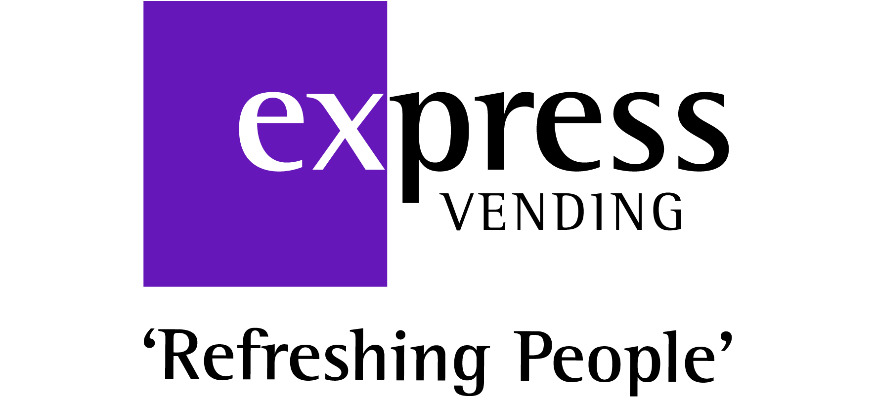 |  | Services Business Uses Cloud-Based CRM to Boost Sales Management and Efficiency
“The result is that salespeople will save vast amounts of time by being able to update appointments on the move. The salesperson’s efficiency on the road will be greatly increased.”
Katy Holden, Sales Manager, Express Vending
The need for an efficient, streamlined database to improve sales and customer service led Express Vending to deploy Microsoft Dynamics CRM Online. The Microsoft Dynamics CRM solution that the firm now has in place has met and exceeded its key business needs. The uptake and feedback from both salespeople and managers has been positive, with better visibility and access to data leading to increased sales opportunities.

Business Needs

Express Vending supplies premium-quality coffee and refreshment vending machine solutions, which are tailored to meet the demands of organisations of any size and type. Having a custom-built customer relationship management (CRM) system was essential for its business.

Historically, Express Vending was using an outdated sales database called Goldmine. The information on
the system was becoming increasingly unreliable, and data was hard to
extract and analyse. Sales and order processes were being managed using spreadsheets and paper-based systems. Express Vending needed a streamlined database to minimise confusion and mistakes. The firm wanted to deploy an efficient CRM system that provided salespeople and managers with fast, reliable access to CRM tools, from both the office and remotely, using tablets and smartphones. Katy Holden, Sales Manager, Express Vending, says: “We needed a whole database overhaul—to completely rethink the way in which our salespeople worked, and also to integrate our new system into our other internal processes.”

A key challenge for Express Vending was creating a CRM system that improved customer service by having up-to-date records on customers and prospect accounts. It also wanted to help its salespeople by making account information easily accessible. In addition, the new system needed to be used by managers to analyse sales.

Solution
Express Vending put out a request for tender for the project, inviting five companies to respond. “The CRM Business delivered the most exciting presentation and understood our business needs most comprehensively. We had previously considered using Salesforce.com, but Roger Collins, Managing Director of The CRM Business, persuaded us otherwise by demonstrating the power of Microsoft Dynamics CRM. It seemed to meet all of our business needs and offered additional functionality that we hadn’t initially considered,” says Holden.

The CRM Business had in-depth consultation meetings with Express Vending, ensuring that all work was scoped in detail before commencing the project. Holden says: “Being the Project Manager from the client side, this certainly gave me confidence that The CRM Business was making sure it really got to know all of our intricate internal processes. We run a fast-paced sales floor, so it was vital that the move to our new system was seamless. The early and highly detailed scoping sessions with The CRM Business helped us make the migration as painless as possible.”
Benefits
Express Vending has improved the accuracy and efficiency of its sales team and enhanced client communications since deploying Microsoft Dynamics CRM Online. Its streamlined Microsoft Dynamics CRM solution allows the sales management team to respond to the sales team’s training requirements.

- Better visibility. Live key performance indicator dashboards have motivated team members because now they can see exactly where they are against activity targets and their colleagues. Sales managers have increased visibility of activities, so they can spot potential issues early and address them, tailoring training programmes appropriately.
- Streamlined processes. The sales order process has been streamlined using a custom configurator within Microsoft Dynamics CRM. Salespeople can now effectively “build” their own vending machines, ensuring they get the configuration and price of the equipment exactly right. The sales order process counteracts a large proportion of human error involved in ordering machines because only valid configurations can be selected, saving the firm money by decreasing aborted installs and incorrect machine orders.
- Increased opportunities. Salespeople are able to keep on top of prospects and leads because prospects are tracked in Microsoft Dynamics CRM from the point that the first meeting is booked. Weekly forecast meetings can now also be led directly by the opportunity pipeline logged on Microsoft Dynamics CRM, increasing the salesperson’s accountability for managing their prospects closely and accurately.
- Accessible data. With Microsoft Dynamics on tablets and smartphones, data is easily accessible both in the office and out on the road. “The result is that salespeople will save vast amounts of time by being able to update appointments on the move. The salesperson’s efficiency on the road will be greatly increased and site surveys can be filled out accurately when on site,” says Holden.

