For more information about other Microsoft customer successes, please visit: www.microsoft.com/casestudies
Customer: Clarion Interpreting
Website: www.clarioncall.net
Customer Size: 24
Country or Region: United Kingdom
Industry: Professional services
Partner: Cambridge Online Systems

Customer Profile
Established in 2002 and with an annual turnover of £2.2 million (U.S.$3.3 million), Clarion is a Cambridge-based provider of sign-language interpreting services. Its areas of expertise include education and legal domains such as police stations, courts, tribunals, and probation services.

Software and Services
- Microsoft Dynamics
- Microsoft Dynamics CRM
Microsoft Dynamics
Customer Solution Case Study
 | 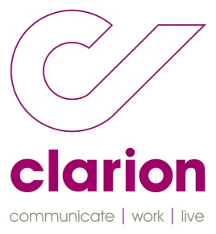 |  | Company Uses CRM Solution to Provide High-Quality, Value-Driven Services
“You can’t improve efficiency unless you have the right tools, and we have them now. We’re more efficient and work at a more competitive rate—all because of Microsoft Dynamics CRM.”
Cheryl Cullen, Head of Business Development, Clarion Interpreting

Clarion Interpreting provides sign-language interpreting services across private and public sectors. It supplies around 50 British Sign Language (BSL) users a day to a variety of clients, including training services firm Ingeus, and Guy’s and St Thomas’ hospitals. Clarion chose Microsoft Dynamics CRM to replace its existing customer relationship management (CRM) solution, increasing productivity and delivering its high-quality services more effectively.

Business Needs
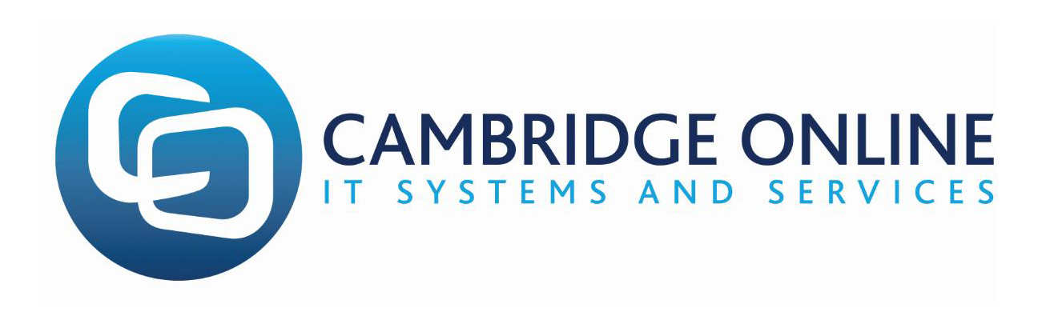 |  |  | 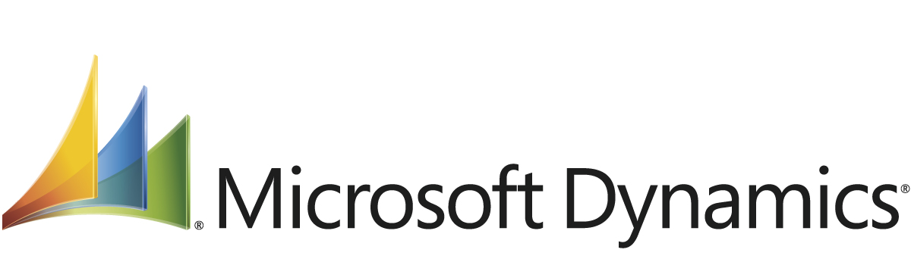

The CRM system employees were using was slow and inflexible—and unable to support the company’s ambitions for growth. The firm knew it needed to perform booking transactions faster, extract timely and accurate management information, and integrate booking data with the accounting system.

The only way to achieve this was to replace the existing system. The company compiled a list of required functionality, which included advanced searches, such as proximity to certain postcodes, and automatic booking confirmations.

Solution
Clarion chose Microsoft Dynamics CRM and selected Cambridge Online Systems to install and customise it to suit the firm’s specific requirements. This included the creation of custom-built components, including a diary view booking system to see available agents at a glance and location searching against specific skills.
Cheryl Cullen, Head of Business Development at Clarion Interpreting, says: “Cambridge Online Systems took the time to learn all areas of our business through structured scoping sessions. This, added to its excellent CRM knowledge enabled it to create a highly effective CRM solution.”

Benefits
The new CRM system has provided a number of benefits to Clarion. Significantly, management now has a clear view of activities and related costs and revenues. Cullen says: “Cambridge Online Systems and Microsoft Dynamics CRM have made significant improvements right across our business.”

- Increased productivity. Clarion has seen a 50 per cent productivity gain because the booking process as a whole is faster and more intuitive—a decrease of about 6 minutes per booking. This means managers are now confident that they can expand the business by more than 50 per cent without having to employ more booking staff. This, in turn, reduces the internal cost of making a booking. “These savings can potentially be passed onto the customer, making our prices even more competitive in a crowded market place,” says Cullen.
- Real-time information. Cullen says: “We can clearly see which communications solutions are being used in various markets and the gross profit margins they secure.” Managers are now able to drill down and see the gross profit margin on each booking. They also have useful information at hand to help them define their marketing strategies. “And key performance indicator (KPI) reporting for customers is no longer a time-consuming manual process—it’s now automated. It saves us days, and, as a result, adds value for our new customers,” says Cullen. “We can see related costs on a project straightaway and don’t have to delay our reporting while we wait for them to come in.”
- Easier procurement. Management can quickly find out the value of work they’ve given to an individual interpreter over a period of time. They can then use this information to negotiate and buy services in relation to volume of work offered. This boosts the company’s ongoing profit margin. “We can even help our freelancers by sending them a statement with the same information for their tax returns. This improves our relationship with our freelancers,” says Cullen.
- Reduced finance administration. The finance team is now able to use the system to raise invoices seamlessly without the need for a back-office program. Invoice data is therefore exported directly into the company’s finance software. “This efficiency has allowed us to redeploy a finance member of staff onto credit control, which has significantly improved our cash flow position,” says Cullen.
- Metric-driven culture. Performance management has become a much easier task because everyone can clearly see the number of bookings a coordinator is putting on the system—by day, week, or month. Cullen says: “This is really useful because we can, for example, see immediately if a health customer has dropped off over the last couple of days, a week, or a month. It means we can see who’s delivering against the standards we require in our booking office. This metric-driven culture gives us snapshots into areas such as market, product, and income. These are used for business intelligence but also to motivate and celebrate our successes.”
- Remote access. Team members can access all they need on the system when they’re on the move. This helps them prepare for meetings because they can look at a customer’s contact and transaction history. “Our office is in the countryside,” says Cullen. “So when the weather’s bad and some of us can’t get in, our new system allows us to work remotely as efficiently as if we were in the office.”
- Improved customer service. Since installing the new system, Clarion has conducted a customer survey. “The feedback is outstanding,” says Cullen. “Microsoft Dynamics CRM is allowing us to move from good customer service to great customer service. The system is freeing up our time so we can give that value-added service to customers. We all feel empowered now—both in terms of the information we have and how we use it. You can’t improve efficiency unless you have the right tools, and we have them now. We’re more efficient and work at a more competitive rate—all because of Microsoft Dynamics CRM.”

