For more information about other Microsoft customer successes, please visit: www.microsoft.com/casestudies
Customer: Audio-Technica UK
Website: http://eu.audio-technica.com/en/
Country or Region: United Kingdom
Industry: Manufacturing—Audio and video equipment manufacturing
Partner: eBECS

Customer Profile
Based in Leeds, Audio-Technica is the European arm of Japanese audio equipment manufacturer Audio-Technica Corporation, a manufacturer of high-end headphones and microphones.

Software and Services
- Microsoft Dynamics
- Microsoft Dynamics AX
- Microsoft Dynamics CRM
Microsoft Dynamics
Customer Solution Case Study
 | 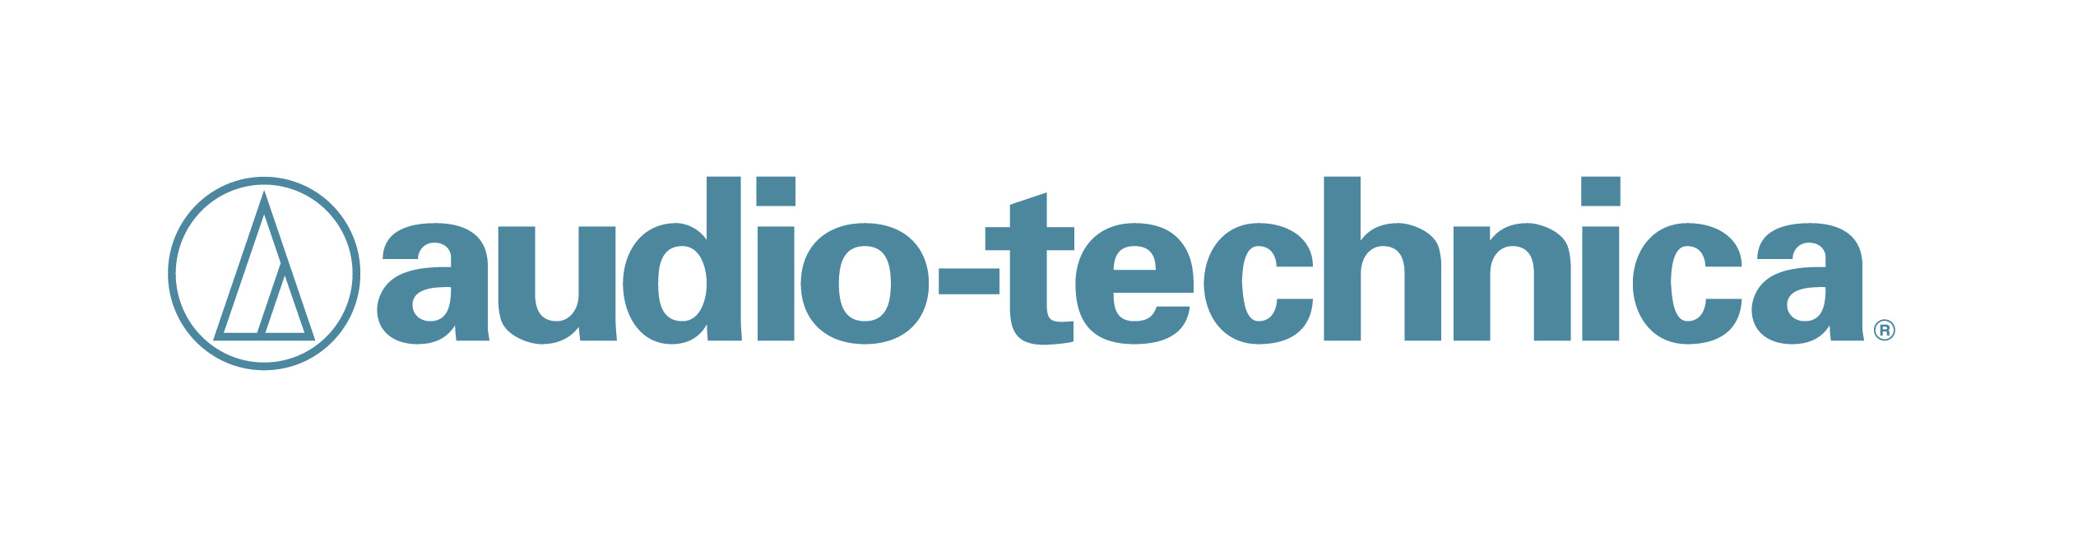 |  | Audio Equipment Firm Improves Decision-Making with Business Management Solution
“The combination of Microsoft Dynamics CRM and Microsoft Dynamics AX gives us a powerful, integrated solution…We wanted more accurate information, with which to make better decisions—and we’ve got it.”
Adrian Rooke, Managing Director, Audio-Technica
With sales growth hindered by its contact management and transaction processing systems, Audio-Technica recognised that it needed cutting-edge customer relationship management (CRM) and enterprise resource planning (ERP) solutions to manage inventory and boost productivity. With Microsoft Dynamics CRM and Microsoft Dynamics AX—implemented by eBECS—the firm has seen performance improve, with detailed insights helping managers make better business decisions.

Business Needs
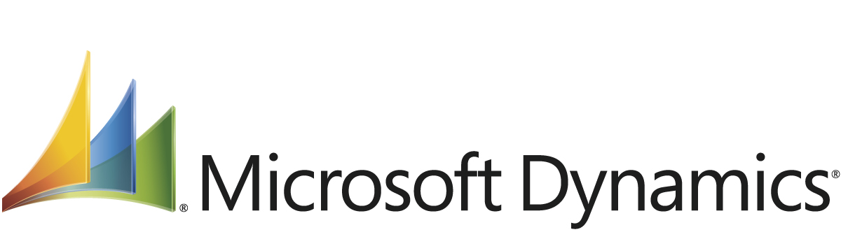

In addition to supplying a network of around 500 dealers across the United Kingdom (U.K.), audio equipment firm Audio-Technica also acts as a central inventory holding for the European operations of Audio-Technica—ordering stock from Japan, repackaging products for European market requirements, and shipping them to dealers across Europe.

In late 2010, the business realised that both its standalone contact management system and third-tier distribution business system were acting as barriers to growth.

Adrian Rooke, Managing Director, Audio-Technica, says: “We wanted to make CRM central to everything we do, helping to differentiate our offering in a competitive market. But we also recognised that not only did our core business system need upgrading to a full ERP system, but it also needed to be integrated with a comprehensive CRM system.”
But the firm’s requirements were complicated.

The existing contact management system provided sales representatives with an offline copy of the CRM database. This meant they could consult it while on the road and prepare post-visit reports shortly after leaving a customer’s premises.

And while the business wasn’t a traditional manufacturer, its functions embraced more than just distribution. Routinely, for instance, products were repackaged, combined together with other products to be sold as bundled sets, and shipped with localisation options specific to particular markets.

“It’s ‘assemble-to-order’ rather than true manufacturing—but with an extended supply chain stretching back to Japan,” says Rooke. “Increasingly, visibility into incoming shipments was becoming more and more important in terms of customer service and efficient inventory management.”

Solution
The search began for a solution, with CRM being considered the most important factor.

Audio-Technica identified only four offerings that met the majority of its requirements, and just one—Microsoft Dynamics CRM—that met the firm’s need for offline access.

But Audio-Technica wasn’t prepared to compromise. Rooke says: “CRM was going to be critical in helping us deliver a sustainable high-quality service. We knew that being able to deliver this would keep customers coming back. What’s more, delivering a sustainable high-quality service would help to change the conversation with customers from a price-based discussion to one that revolves around the total package that we offer. But achieving this is difficult without a CRM system, because so much information is in the salesperson’s head—which, of course, is then lost when the salesperson moves on.”
With the CRM solution chosen, the decision regarding which business system to deploy was also quickly made. The firm chose Microsoft Dynamics AX sourced from and implemented by eBECS—Microsoft Gold Partner and Microsoft Dynamics Reseller of the Year in 2012—which also provided data mapping and integration services.

“It was quickly clear that the combination of Microsoft Dynamics CRM and Microsoft Dynamics AX gives us a powerful, integrated solution,” says Rooke. “New customers would begin as prospects in Microsoft Dynamics CRM, and seamlessly transition to a customer relationship within Microsoft Dynamics AX. We’d get a 360-degree view of not only the sales order process, but also the inventory management and assembly processes that fulfil those orders.”

eBECS played a critical role, not only in helping Audio-Technica understand what Microsoft Dynamics AX and Microsoft Dynamics CRM could deliver, but also how best to deploy and use them for maximum benefit.

Rooke says: “eBECS started with what we wanted to achieve, and how we wanted to achieve it—not with some predetermined view of what we should do, and how we should do it,” he says. “The result is a solution that’s completely ours, and that meets our specific requirements.”

Benefits
In place since early 2012, the combined ERP and CRM solution has delivered significant benefits to Audio-Technica. The integrated, state-of-the-art solution gives the audio equipment firm more accurate information, helping it make well-informed decisions that keep it ahead of its competitors.

- Integrated solution helps improve decision-making. The integrated nature of the solution has enabled Audio-Technica to make significant productivity gains, with people no longer maintaining standalone spreadsheets and similar tools. But, more importantly, the combined solution has delivered on its promise of transforming the firm’s customer-facing and inventory-management processes, helping to fuel business growth. Rooke says: “We wanted more accurate information, with which to make better decisions—and we’ve got it.”
- Cutting-edge technology and expert support give peace of mind. The company now has the reassurance of knowing that it’s using state-of-the-art technology sourced from a major vendor, and supported by one of the U.K.’s leading specialists in Microsoft Dynamics AX and Microsoft Dynamics CRM.

