Microsoft Dynamics
Customer Solution Case Study
 | 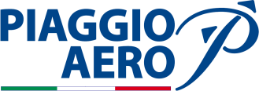 |  | Aeronautics Leader Deploys ERP Solution to Streamline, Control, and Grow Its Business

Overview  Country or Region: Italy  Industry: Manufacturing—Aerospace and industrial manufacturing  Customer Profile  Aviation industry leader Piaggio Aero Industries is the world’s only company that designs, manufactures, and services aircraft, engines, and engine components.  Business Situation  The company sought to streamline its business processes, more closely connect locations and business groups, and gain better control over business growth and performance.  Solution  Piaggio Aero deployed Microsoft Dynamics AX in several business units, including the company’s finance management, and integrated the solution with Microsoft Project Server and Microsoft SharePoint Server.  Benefits  - Generate cost savings through streamlining and control  - Enable business insight and dependable regulatory compliance  - Gain higher returns from investments in skills and training  - Rebuild business processes for growth and best customer service |  |  | “With Microsoft Dynamics AX, we can better devise and run extended processes, manage more-than-doubled data volumes, and meet business challenges with great agility.”  Enrico Cafiero, Head of Business Information Systems and ERP Program Manager,  Piaggio Aero Industries
 |  |  | Piaggio Aero Industries operates a complex business with multiple locations, diverse business units, stringent regulatory and quality standards, and demanding customer commitments. The company’s legacy software was difficult and expensive to operate and maintain and was unable to support efficient operations. Engaging with Microsoft partner MHT, Piaggio Aero implemented Microsoft Dynamics AX as a centralized business management solution. The solution offers information and insight to the people who need it and helps rebuild business processes for best productivity. Now, Piaggio Aero realizes substantial cost savings, higher returns on investments in skills and expertise, and easier, more dependable regulatory compliance. With its new, streamlined business infrastructure, the company also can quickly take new products to market and adjust to market changes.
 |  |  | 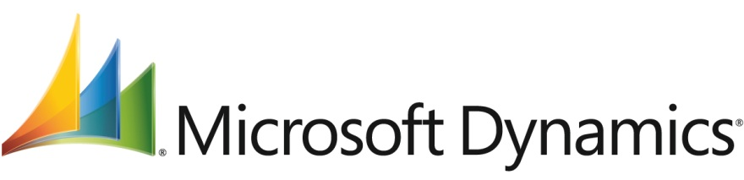

Situation
“With the integration of Microsoft Dynamics AX with SharePoint Server, decision makers in all company locations can easily share information. Managers have immediate access to information. We now can align capacity with sales forecasts, production planning, and customer agreements and make sure we meet our goals and commitments efficiently and predictably.”
Enrico Cafiero, Head of Business Information Systems and ERP Program Manager, Piaggio Aero Industries

Piaggio Aero Industries, founded in 1998 and headquartered in Genova, Italy, is the only aeronautics company in the world that designs, manufactures, and maintains airplanes, airplane engines, and engine parts. Most of the company’s manufacturing and service centers are located close to civil and military aviation facilities in northern and central Italy. The company’s planes and engines are known for innovative designs and advanced levels of performance. The aircrafts that Piaggio Aero manufactures, such as the P180 Avanti II, are used in private and corporate aviation across the globe. Piaggio Aero’s customers for engines, parts, and maintenance services include Rolls Royce, Honeywell, Pratt & Whitney, and other leading aeronautics enterprises.

Growth of a Complex Business Operation
Piaggio Aero’s business presents many operational complexities related to regulatory compliance, materials management, financial control, resource utilization, and business planning. The company operates four manufacturing and service locations, maintains a complex network of suppliers, and supports a global, diverse group of customers. A typical Piaggio Aero aircraft comprises approximately 35,000 unique parts, which the company must source, ship, track, and account for. Bills of materials for aircraft manufacturing include as many as 25 levels; for engines, they may feature up to seven levels. In addition, the manufacturing of aircraft, engines, and parts and the delivery of maintenance services need to adhere to elevated regulatory standards for quality assurance, safety, and performance.

Customers may impose additional, specific requirements, including the tracking and serial-numbering systems for parts and materials, which Piaggio Aero then needs to incorporate in its business processes. For governmental or military customers, the complexities of reporting, contract and financial management, and materials tracking sometimes can increase significantly. Furthermore, international business and frequent imports of aircraft and engine components contribute additional requirements for finance and materials management and require flawless compliance with customs and regulatory requirements.

Round-the-clock airplane maintenance involves several assistance centers and spare-parts distribution, and adheres to stringent service-level commitments. Enrico Cafiero, Head of Business Information Systems and ERP Program Manager at Piaggio Aero Industries, says, “We had grown to a point where we needed to review our business processes and ensure they helped us gain the best productivity returns from our resources. In addition, we sought to serve customers in an efficient and competitive manner. We wanted to accomplish these goals without increasing employees’ workloads or causing interruptions to workflows.”

Need to Replace Dated, Inefficient Software Systems
However, existing software systems were not ready to support this effort. To manage inventory, manufacturing, sales, purchasing, and invoicing, Piaggio Aero used a custom software system created by the company’s IT group. Although it was periodically updated, based on technology requirements at Piaggio Aero’s inception, the company never comprehensively upgraded the system. Whenever business requirements changed, IT staff developed additional customizations, which could take significant time to create, test, and implement. The software system used batch processing, and obtaining up-to-date business data, such as accurate inventory costs, was not always easy.

This system lacked integration with the company’s multiple applications for managing certain aspects of the business. Users had to record information repeatedly and had to search for it in several applications when they wanted to answer a question. Many important details to do with costing, materials tracking, or customer commitments were therefore exposed to a high likelihood of human error. For financial management, Piaggio Aero used enterprise resource planning (ERP) software from SAP.

Says Cafiero, “We needed a comprehensive, flexible business management solution that could support our complex operation that would help us make our processes more efficient and that we could implement in such a way that would make employees’ jobs easier.”

Solution
Leaders at Piaggio Aero were aware of Microsoft Dynamics AX through their experience at other companies. Their conversations with Microsoft Italy helped them determine that Microsoft Dynamics AX had great potential for meeting the company’s needs. Soon, Piaggio Aero reached out to MHT, a Microsoft partner and one of the leading Microsoft Dynamics partners in Italy, with eight offices in different regions. MHT successfully demonstrated to Piaggio Aero how Microsoft Dynamics AX could help support the company’s business strategy and process optimization.

Replacing Legacy and Custom Systems
Initially, Piaggio Aero and MHT decided to implement Microsoft Dynamics AX 2009 in the engine parts–manufacturing business and use the experience to deploy the solution with great efficiency and reliability across all business operations. Subsequently, they deployed the solution in the airplane-manufacturing business unit and in the airplane maintenance and service group. In addition, Microsoft Dynamics AX became available for financial management across the entire organization, and Piaggio Aero phased out both the SAP and legacy systems. Today, close to 400 employees in four Piaggio Aero locations use the solution to perform their jobs. “Replacing our legacy system, which we developed in-house and customized through the years, with the out-of-the-box functionality of Microsoft Dynamics AX immediately offered opportunities for IT efficiencies and allowed the IT team to play a new role in supporting the business,” says Cafiero.

Creating an Integrated Business Infrastructure
Piaggio Aero integrated Microsoft Dynamics AX with Microsoft Project Server to help plan and monitor the more than 400 assembly steps for each plane the company makes. The company organizes airplane manufacturing as a production chain, working with the integrated solution to maintain lean-manufacturing practices for the airplanes in integration with the production of their components. Cafiero explains, “We maintain the planning in Project Server and manage detailed assembly information in Microsoft Dynamics AX. We track the progress of manufacturing cycles in both systems, but it’s through Microsoft Dynamics AX that we get detailed financial and operational reporting and control.”

In addition, Microsoft Dynamics AX integrates with Microsoft SharePoint Server to distribute business analysis and other information to specific groups of Piaggio Aero employees. Specific workflows that Piaggio Aero has implemented in SharePoint Server include consistent management of master data and the creation of new part numbers, which involves stakeholders from several different business areas and requires firm controls.

Following Proven Best Practices for
ERP Implementations
To prepare and plan the implementation project, MHT made use of its own adaptation of Microsoft Dynamics Sure Step resources and best practices. As is customary in projects guided by Sure Step methodology, Piaggio Aero and MHT collaborated closely to define project needs and goals and to streamline the deployment process as much as possible. The methodology also helped Piaggio Aero and MHT keep customizations—for example, in shop-floor control and material requirements planning—to a manageable and cost-efficient minimum.

Introducing New Efficiencies into Business Processes
One of the first and most sought-after capabilities Piaggio Aero gained was the ability to perform complete lot tracking with Microsoft Dynamics AX. Piaggio Aero also began using the solution’s configuration tools to establish and document the design of engine parts. Then, immediately following the manufacturing functionality, MHT implemented functionality into Microsoft Dynamics AX to facilitate the purchasing and distribution of engine parts together with materials and inventory management. Next, MHT adjusted the solution to ease compliance with customs reporting and payment of duties for imported parts.

During the implementation, Piaggio Aero took advantage of the solution and MHT’s expertise to simplify business processes and make them more consistent. That included, for example, shipping, which earlier required ample, paper-based documentation and involvement from knowledgeable experts within the company. “We value MHT as a resourceful, experienced, and accountable technology partner,” says Cafiero. “MHT did outstanding work in helping us keep the implementation on track and ensuring that we obtained the results we hoped for.”

Benefits
For Piaggio Aero, Microsoft Dynamics AX serves as a strategic, centralized business management tool that connects the company’s employees, business groups, and locations; makes reliable, current data universally available; and helps structure business processes for growth and best efficiency. Says Cafiero, “Implementing Microsoft Dynamics AX was a turnaround point in managing through a difficult economy. With the solution, we can run an efficient operation that can rapidly adjust to changing market conditions. Across the back office and the customer support organization, we can now be much more timely, responsive, and consistent in developing successful approaches to serving our market.”

Generate Cost Savings Through Streamlining and Control
By replacing legacy ERP, specialized, and in-house developed software systems, Piaggio Aero can take advantage of valuable IT skills in more business-critical activities and save the expense and effort of maintaining these systems. As Cafiero explains, “The costs of licensing, operating, and managing Microsoft Dynamics AX are significantly less than the costs of operating and supporting the previous systems.”

In several business processes, including procurement, ground maintenance, sales support, and transportation, Piaggio Aero realizes cost savings through efficiencies; a review to establish the actual amount of the savings is currently underway. “With all business information available throughout the organization, we have much better cost control,” explains Cafiero. “Just one example: With Microsoft Dynamics AX, we gained the ability to track actual inventory costs, which we can now consider to achieve greater cost-efficiencies in our planning, sourcing, and manufacturing. With the better planning that we can now perform, we also reduced our inventory levels substantially, generating further savings.”

Enable Business Insight and Dependable Regulatory Compliance
“Across the back office and the customer support organization, we can now be much more timely, responsive, and consistent in developing successful approaches to serving our market.”
Enrico Cafiero, Head of Business Information Systems and ERP Program Manager, Piaggio Aero Industries

The Piaggio Aero management team takes advantage of the solution’s reporting capabilities to set up relevant business metrics and assess business performance in real time. For example, the company no longer needs to wait for batch processing or manual data collection to complete. The solution’s business intelligence capabilities are critical in such areas as materials planning, workload management, and change management. Cafiero explains, “With the integration of Microsoft Dynamics AX with SharePoint Server, decision makers in all company locations can easily share information. Managers have immediate access to information. We now can align capacity with sales forecasts, production planning, and customer agreements and make sure we meet our goals and commitments efficiently and predictably.”

Reporting to ensure compliance with regulatory mandates, including Italian Civil Aviation Authority and Federal Aviation Administration reporting, is easier to produce than in the past, because the confidence in the integrity of the information is much higher. “Regulatory compliance today is a streamlined, efficient effort, and the sense of assurance we can provide to managers, regulators, and auditors is extremely high,” says Cafiero.

Gain Higher Returns from Investments in Skills and Training
Technology users at Piaggio Aero experienced dramatic changes in the ease-of-use of the software tools they use every day. With Microsoft Dynamics AX, employees have an intuitive interface that is consistent with the other applications they frequently use, such as Microsoft Word, Microsoft Outlook, and Microsoft Excel. It also makes all information pertinent to specific roles available in a single screen. “The biggest change is in how easy it is for people to be consistently effective in their jobs,” says Cafiero. “Microsoft Dynamics AX and the other Microsoft technologies help employees greatly in serving customers and collaborating with each other and with our business partners.”

It is also easier for employees to contribute to business process improvements. Says Cafiero, “As we replaced paperwork and manual checkpoints with automation and consistent workflows, people gained a better understanding of possible efficiencies and could think more about transforming tasks and processes with the best productivity in mind.” In addition, the planning and resource management capabilities in Microsoft Dynamics AX help Piaggio Aero move skilled, specialized employees from one business group to another as needs change. Many individuals’ skills are easily transferable within the company, and the presence of a single, centralized business management solution means these professionals continue to work within a familiar, intuitive software environment. Says Cafiero, “By using Microsoft Dynamics AX, we’ve realized a substantially higher return on the company’s investment in the acquisition and development of employee skills.”

Rebuild Business Processes for
Growth and Best Customer Service
By implementing Microsoft Dynamics AX, Piaggio Aero has replaced expert systems, paper-based documentation, and complicated business processes with a unified business management solution that supports all of the company’s activities. Improved business processes help the company align more closely with customer needs and run a leaner, more agile operation. “All of our business information is now in the form of consistently structured data,” says Cafiero. “That helps us streamline many processes and make huge improvements in the effectiveness of our managers.”

For example, the formerly unwieldy process of shipping engine parts, which included printed documentation and required experienced team members to painstakingly control, is now fully standardized in the solution. And, with the ability to efficiently track thousands of engine parts by serial numbers through a standardized process or customized for specific customer requirements, Piaggio Aero works more efficiently with suppliers and serves customers with greater flexibility. Piaggio Aero also expects Microsoft Dynamics AX to be a critical factor as the company grows new areas of the business. Says Cafiero, “We are building an entirely new airplane model and taking the production of engine components to a much higher level. With Microsoft Dynamics AX, we can better devise and run extended processes, manage more-than-doubled data volumes, and meet business challenges with great agility.”
The P180 Avanti II planes from Piaggio Aero are used in private and corporate aviation across the globe.
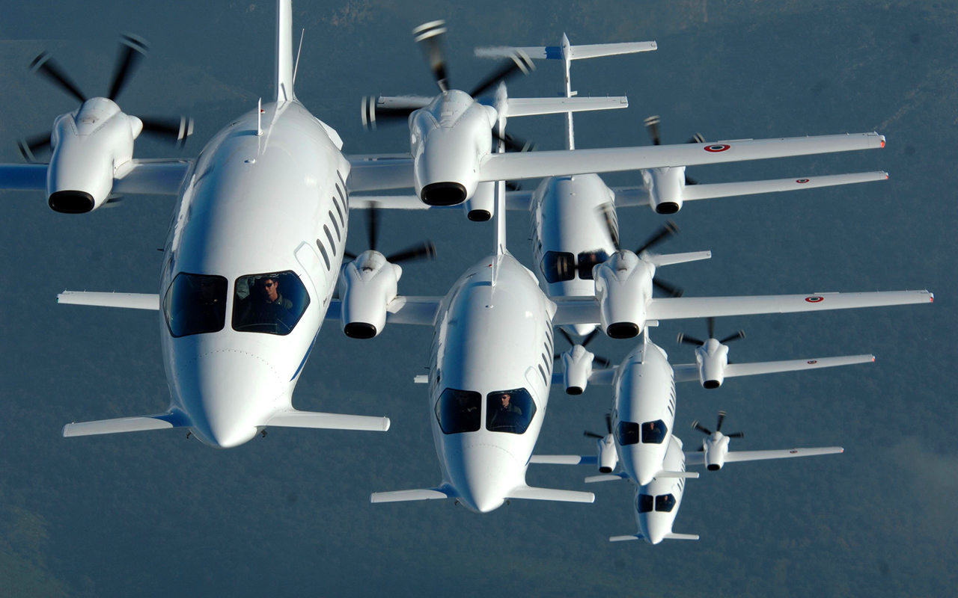
Microsoft Dynamics
This case study is for informational purposes only. MICROSOFT MAKES NO WARRANTIES, EXPRESS OR IMPLIED, IN THIS SUMMARY.

Document published January 2012

For More Information
For more information about Microsoft products and services, call the Microsoft Sales Information Center at (800) 426-9400. In Canada, call the Microsoft Canada Information Centre at (877) 568-2495. Customers in the United States and Canada who are deaf or hard-of-hearing can reach Microsoft text telephone (TTY/TDD) services at (800) 892-5234. Outside the 50 United States and Canada, please contact your local Microsoft subsidiary. To access information using the World Wide Web, go to:
www.microsoft.com

For more information about Piaggio Aero Industries products and services, call 39 010 6481 987or visit the website at:
www.piaggio.com

For more information about MHT products and services, 39 010 6481 987 or visit the website at:
www.mhtnet.it/en_index.html
Microsoft Dynamics is a line of integrated, adaptable business management solutions that enables you and your people to make business decisions with greater confidence. Microsoft Dynamics works like familiar Microsoft software such as Microsoft Office, which means less of a learning curve for your people, so they can get up and running quickly and focus on what’s most important. And because it is from Microsoft, it easily works with the systems that your company already has implemented. By automating and streamlining financial, customer relationship, and supply chain processes, Microsoft Dynamics brings together people, processes, and technologies, increasing the productivity and effectiveness of your business, and helping you drive business success.

For more information about Microsoft Dynamics, go to:
www.microsoft.com/dynamics

Software and Services  - Microsoft Dynamics  - Microsoft Dynamics AX  - Microsoft Server Product Portfolio  - Microsoft Project Server  - Microsoft SharePoint Server | Partners  - MHT

