Microsoft Dynamics
Customer Solution Case Study
 | 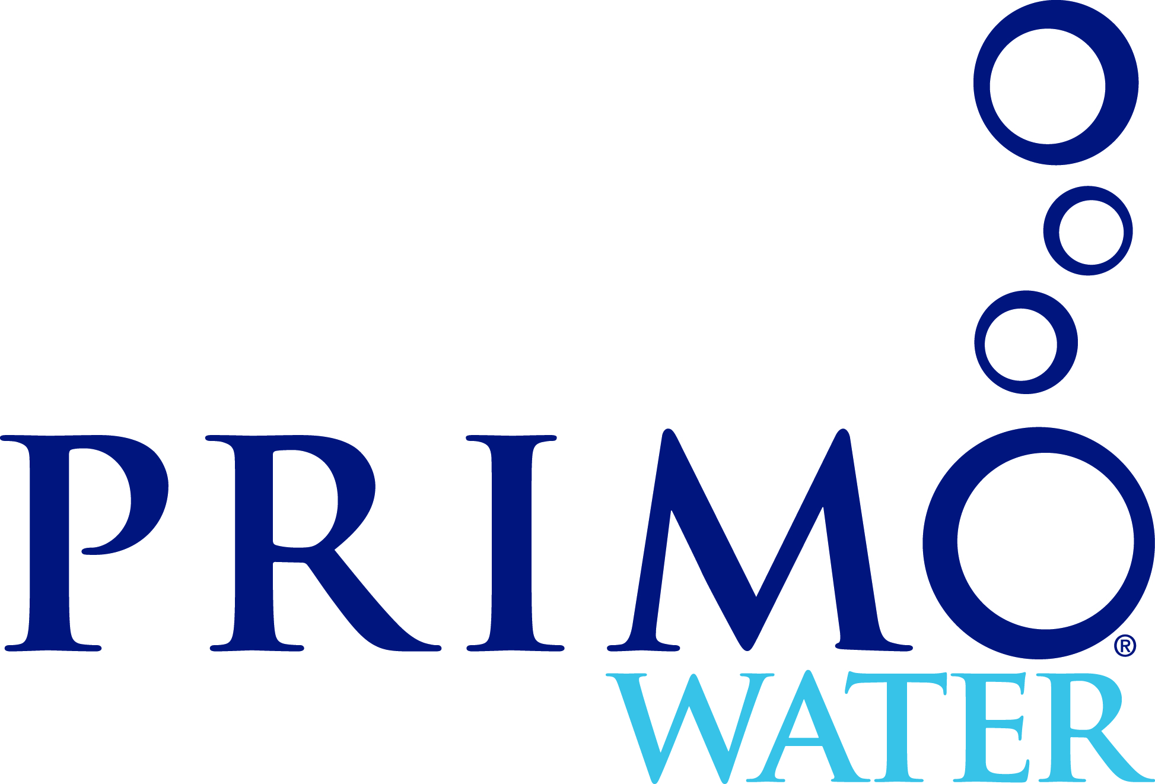 |  | Water Distribution Start-up Uses Microsoft Dynamics® to Manage Growth and Drive Business Value

Overview  Country or Region: United States  Industry: Wholesale and Distribution – Consumer Goods/Beverages  Customer Profile  Primo Water Corporation provides 3 and 5 gallon bottled water and water dispensers. The company was founded in 2005 and is based in Winston-Salem, NC.  Business Situation  Primo Water needed an ERP system to support its business and growth, but wanted to avoid the complexity and high costs that often come with larger, more drawn out implementations.  Solution  Primo Water selected Microsoft Dynamics GP to manage growth, gain tighter control over its business processes, and maximize the value of its technology investment.  Benefits  - Reduced Days Sales Outstanding by 25%, and bad debt by U.S.$200,000  - Better inventory visibility: increased service level, reduced lost sales by 50%  - Tighter control on business functions: reduced legal and audit expense by U.S.$35,000  - Streamlined processes through systems integration: resulted in labor/time savings of U.S.$200,000 annually |  |  | “Combination of licensing, powerful built-in features, and ease-of-use all came together with a capable integration partner making it an easy decision [to select Microsoft Dynamics GP] versus an open source or other mid-tier application.”  Mick Gunter, Senior Vice President of Operations, Primo Water Corporation
 |  |  | Primo Water Corporation, based in Winston-Salem, NC, is the leading supplier of bottled water dispensers in the US. The company operates in two segments - Primo Bottled Water Exchange that sells 3 and 5 gallon bottles of purified water and Primo Products that sells water dispensers for those and other compatible bottles. As a privately owned, fast-growing start-up firm, the company quickly outgrew the capabilities of their QuickBooks accounting software and chose to migrate to Microsoft Dynamics® GP. Primo Water needed a comprehensive solution to take advantage of the technology capabilities, but wanted to avoid the complexity and high costs that often come with larger, more drawn out implementations. By adopting and upgrading to the latest version of Microsoft Dynamics GP, Primo Water achieved added business value, while being able to deploy the solution quickly and affordably.
 |  |  | 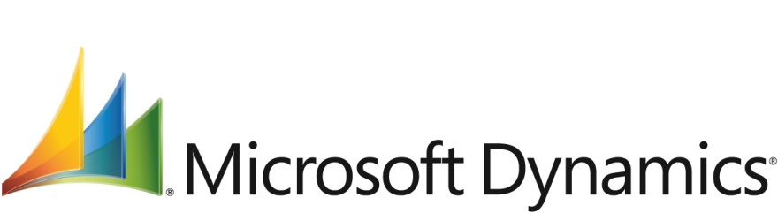

Situation
“Real time communications and access to data across vendors, partners, and customers is critical to our success. Microsoft technology has been invaluable to create an electronic ecosystem for all these independent businesses to operate in.”
Mick Gunter, Senior Vice President of Operations, Primo Water

Primo Water Corporation was launched in 2005 with seven people through venture capital funding. Since then, the company has grown to more than 70 people generating almost U.S.$47 million in annual revenue, as of 2009. Their Water Exchange segment provides 3 and 5 gallon bottles of purified water to over 7,900 retail outlets across the United States. Their Products segment sells water dispensers through approximately 5,500 retail outlets. Primo Water relies on a national network of about 100 independent bottlers and distributors.

With the distribution and bottling outsourced to independent partners, Primo Water acts as a branding and marketing company. Primo Water ensures strict quality control on the water production process, and provides the tools and applications for these partners to operate the business in their physical space. “Real time communications and access to data across vendors, partners, and customers is critical to our success,” Mick Gunter, Primo Water’s Senior Vice President of Operations states, “Microsoft technology has been an invaluable platform to create an electronic ecosystem for all these independent businesses to operate in.”

A critical requirement of this electronic ecosystem was to integrate and combine sales, accounting, inventory, and operational data via a single solution, and also make this data available to the bottlers and distributors using Web-based applications and Microsoft® SharePoint® 2010 portals. Having a unified and accessible database was necessary for Primo Water to streamline and automate many of its manual business processes, thus increasing productivity and reducing the cost of operations. Also, as the company grew in both Water Exchange and Products segments, it became crucial for management to have complete visibility over its business processes in order to achieve better inventory control, cash management, improve service levels, and increase profit margins.

When the business launched in 2005, Primo Water started with QuickBooks, but quickly realized the need to invest in a more scalable business platform to support their vision of growing to a strong and profitable company today, and a U.S.$200-$300 million revenue company in the future. Primo Water was already working on a roadmap to integrate their ERP and CRM systems, use workflows to simplify their business processes, and extend the reach and visibility of this critical information to other users. As Gunter explains, “We were always investing in this roadmap and vision.”

Keeping with their growth strategy, in the summer of 2010, Primo Water announced plans to acquire the vended-water business of Culligan Store Solutions, which would add 50% to its current revenues. Primo Water had started the IPO process, which made it crucial to have systems in place that will allow tighter control over their processes and drive value for their business.

Solution
Primo Water needed a scalable solution that would integrate with other Microsoft and vertical business applications and remain flexible for future growth. The solution would be expected to automate and streamline most of their business processes, extend the reach of information to employees and partners, and maximize the value of their technology investments. After reviewing multiple options, Primo Water decided to implement Microsoft Dynamics® GP in 2005 with help from Microsoft partner InterDYN-Artis. “The combination of licensing, powerful built-in features, and ease-of-use all came together with a capable integration partner making it an easy decision [to select Microsoft Dynamics GP] versus an open source or some other mid-tier application,” says Gunter.
“Primo can integrate [a] vast majority of the processes within 30 days. Payables of both divisions will be on [Microsoft Dynamics] GP at day zero. We will be able to take their manual order fulfillment process and easily integrate in to existing EDI."
Dana Warren, IT Director, Primo Water

As new technology innovations became available, Primo Water kept up to date with the latest releases of Microsoft Dynamics GP. They deployed Microsoft Dynamics GP 10.0 towards the end of 2008, and were an early adopter of Microsoft Dynamics GP 2010. With each upgrade, Primo Water realized they could achieve much greater business value, but still deploy the solution quickly and at a comparatively low cost.

Quick deployment and low customization needs
Microsoft Dynamics GP supports rapid implementation and system migration. Historically, Primo Water had invested considerable time on consulting to customize and support its business management solution. Heavy tailoring also led to productivity disruptions during deployment in functions driven by these custom codes. With the new releases, however, they were able to cut down significantly on the need for customization and consulting – practically eliminating consulting costs from approximately U.S.$300,000 in 2008 to almost zero in 2010. For the current version, Primo Water spent only about 140 hours in planning for deployment, customization, and testing. Also, they were able to install the server software and set up user accounts to get all users live on the system in just 10 hours, thus reducing the impact of employee downtime.

The industry-standard integration features of Microsoft Dynamics GP 2010 allowed them to quickly and easily connect with external applications (such as EDI, Microsoft Dynamics CRM) and reap significant benefits immediately. Moreover, with the new Culligan acquisition expected to close by the end of 2010, Primo Water’s IT department is confident that they can achieve post-acquisition integration of the systems in no time. As Dana Warren, IT Director for Primo Water explains, “Primo can integrate [a] vast majority of the processes within 30 days. Payables of both divisions will be on [Microsoft Dynamics] GP at day zero. We will be able to take their manual order fulfillment process and easily integrate in to existing EDI.”

Drives business value at low predictable costs
Microsoft Dynamics GP offers simple and flexible licensing allowing businesses to select and pay for specific components and user types that meet their unique business needs. Primo Water was able to save on their overall license costs by paying for a smaller number of full access concurrent users, while affordably extending valuable insights of the ERP solution to more people across their organization with additional light user licenses.

By deploying Microsoft Dynamics GP as a part of the Microsoft Business Ready Enhancement Plan (“BREP”), Primo Water is able to get more out of their solution at a much lower and predictable cost. BREP provides a simple annual pricing model based on the number of concurrent users and offers multiple benefits, including: upgrades to newer versions of the application when they become available; fixes, updates, service packs, and tax and regulatory releases; and unlimited access to the Microsoft Dynamics CustomerSource site with around-the-clock support, online training, and community-based services.

Simple to learn and use
Primo Water has an IT staff of only 4 people that supports the entire technology infrastructure as well as the more than 70 employees. This made it extremely difficult for them to allocate time and budget to meet individual employee training needs. However, Microsoft Dynamics GP provides users with a simple to learn and use environment, with the look and feel of the Microsoft Office® software, to access and work with business information. Also, the role-based personalized interface and intuitive task panes helped users quickly access the information that is relevant to them. This allowed Primo employees to independently navigate and learn the system quickly, without relying extensively on IT. For instance, the Accounting department trained itself in both using Microsoft Dynamics GP and their day-to-day business functions. This was possible through the self-service online training tools and all the help available within the software. “I can get everything I need from ‘F1’ [Help] and get step-by-step instructions on getting things done. It has [a] lot more information than any other software I have worked with. If I had to hire someone, I will choose someone with [AR] collection experience and can easily teach [Microsoft Dynamics] GP,” says Mindie Pegram, Accounts Receivable Manager for Primo Water.
“I can get everything I need from ‘F1’ [Help] and get step-by-step instructions on getting things done. It has [a] lot more information than any other software I have worked with."
Mindie Pegram, Accounts Receivable Manager, Primo Water

Figure 1: Financial benefit/ROI from Microsoft Dynamics GP deployment
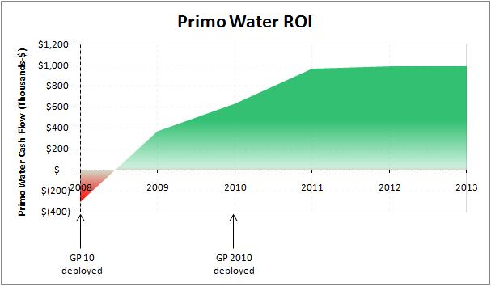
Benefits
Apart from the benefits realized through the rapid implementation and ease-of-use characteristics of the solution, the deployment of Microsoft Dynamics GP 2010 has given Primo Water proven, insightful, and efficient tools that allow users to work faster and smarter.

Boost efficiency and save time by integrating information across systems/applications
The industry standard and simplified integration capabilities, as provided by the Microsoft Dynamics GP Developer Toolkit, allowed Primo Water to integrate other third party applications and streamline many business processes. Primo Water automated the distributor payments, invoice matching, and customer order intake processes, and also integrated an EDI application for their Products business, resulting in almost U.S.$200,000 of annual savings from reduction in time and labor. Employees now have more time than before these enhancements and are able to carry out or contribute to other activities, spend more time on analysis, and focus on the management functions. As Pegram points out, “With the enhancements we had from [Microsoft Dynamics] GP and the things that [the IT] team has worked on as well, it's [a] day and night difference in AR [Accounts Receivable]. We just think they are heroes, as it has really helped us in AR.”
“With the enhancements we had from [Microsoft Dynamics] GP and the things that [the IT] team has worked on as well, it's [a] day and night difference in AR [Accounts Receivable]. We just think they are heroes, as it has really helped us in AR.”
Mindie Pegram, Accounts Receivable Manager, Primo Water

Field agents (the driver distributors) produce approximately 31,000 delivery ticket tracks in a month when they make shipments at retail locations. Previously, Primo Water followed an extremely manual and people-intensive process that would require pulling information from multiple locations or Microsoft Excel® reports and then translating them into tickets payable to the distributors/regional operators. Through a custom built tool – “ROPY” (Regional Operator Payments) – integrated with Microsoft Dynamics GP via eConnect, Primo Water was able to automate this process. By connecting to a unified database, Primo Water automated the receivables (invoice created for customers), payables (payable created for the distributor), and inventory (inventory adjustments) functions – reducing an 80 hour process every month by more than 80%.

The Products business (which sells the water dispensers) follows a very tight process of same day shipment and next day invoicing. Integration with vSync (a third-party EDI solution built specifically for Microsoft Dynamics GP) proved to be extremely crucial. It helped a growing business that started only in 2007 to reach almost 60% of retail market share by 2010. EDI integration streamlined many of the manual order-fulfillment processes (managing inventory updates, receipts and bills, label printing, etc.) and eliminated multiple points of data entry (hand-keying every order, address, tracking, and invoice numbers, etc.). This contributed to labor savings of at least 3 business days per week and allowed their staff to work on other functions.

Through CashApp (a custom Web application using SQL Server stored procedures) integration with Microsoft Dynamics GP, Primo Water used simple rules tables to streamline the process of invoice number matching and applying cash. CashApp converted the highly transactional and manual process, which used basic lockbox processing, to a task of simply verifying/reviewing the matched results, resulting in savings of 2 business days per week and eliminating the need to hire an additional analyst/collector.

Integration with Microsoft Dynamics CRM helped the Accounts Payables (AP) team to automate the process of doing cash requirements and handling Product and Water refunds from the customers, which used to be another labor and data intensive process for Primo Water. But with the CRM integration, the customer now keys in the data into the system and the information gets pushed into Payables module automatically, eliminating any manual effort required by the AP team.

Primo Water also used a Web storefront integrated via eConnect to automate the order intake process for the distributors and bottlers. The web provisioning of customer orders reduced order intake time by approximately 70% and improved order accuracy and customer satisfaction by eliminating the need to receive orders via phone, email, or fax.

Improve cash management and collection process through automation
Built-in workflows mean that employees have better communication and visibility throughout the customer provisioning process. In 2009, customer provisioning took place over emails and was inaccurate 9 out of 10 times with incomplete or garbled payment and delivery terms, shipping address, and other information. This made it difficult to get paid on time by the customers; and if the delay was more than 90 days it required twice as much time and effort to extract these payments. Now, the entire process of customer provisioning is automated and uses automated workflows, which allows better visibility into the entire process. Primo Water can now handle customers proactively and intelligently, and identify any issues or problems much sooner in the process. This has also helped improve customer relationships as they have a better understanding of terms up front. Overall, Primo Water was able to reduce Days Sales Outstanding (DSO) by 25%, and are well on the way to their target of cutting DSO metric in half. This translates to improved working capital and reduced borrowing costs. “We were able to reduce our old collections over 90 days by U.S.$500,000 last year,” explains Diane Pitts, Assistant Controller at Primo Water, “[Microsoft Dynamics] GP gave us the visibility to do that.”
“We were able to reduce our old collections over 90 days by U.S.$500,000 last year. [Microsoft Dynamics] GP gave us the visibility to do that.”
Diane Pitts, Assistant Controller, Primo Water

Automated routines and tight integration with Microsoft Office 2010 also allowed employees to perform tasks faster and more accurately, and populate customer correspondence and statements with up-to-date information automatically and with ease. This resulted in approximately U.S.$100,000 of annual savings in terms of labor and stationary costs.

The Collection Module, which Primo Water did not have in the past, allowed them to save time in setting up a collection process with the customers. Previously, the AR team would spend almost two-and-a-half-days each month in gathering information, drafting letters, mailing almost 90 invoices a day, and spending almost U.S.$5 of postage on each invoice. Now, with Microsoft Dynamics GP, the process is completed much faster as statements and collection letters are automatically generated with the right ticket numbers and dollar amounts pulled in from the system. Integration with Outlook allowed electronic document delivery via e-mail, which not only helped document and track customer correspondence in real time, but also helped save substantially on stationary and postage. “We are moving towards becoming paperless. This is our part of our Going Green goal. AP is now paperless. We were amazed that this could be done,” says Pamela Jones, Data Manager at Primo Water. Additional savings were achieved from using out-of-box functionalities of Microsoft Dynamics GP, such as electronic bank reconciliation and EFT handling.

Gain tighter control and proven scalability without compromising on performance
The BREP licensing program ensures regular product updates that include not only product fixes and updates, but also the latest regulatory information. This helped Primo Water stay current with the latest technologies and regulatory changes without having to spend anything additional to meet these requirements. With the announcement to go public, Primo Water has a year to meet Sarbanes-Oxley (SOX) requirements. Microsoft Dynamics GP helps Primo Water meet requirement for transparency and process control. According to Gunter, “To implement SOX would have been a U.S.$100,000-$200,000 project six years ago. Having implemented Microsoft Dynamics GP, we won’t need to spend this now because it allows us to very easily use standard [Microsoft] tools to meet these requirements.” Within the Collection module, Primo Water was able to document all activities with notes, true date, and time stamps on a real time basis and have the tracking history available for all customer accounts. This allowed Primo Water to present the information that auditors need without having to spend time in validating and managing this data, and pulling everything manually from files, emails, notes, and other sources. As Gunter points out, “There is arguably a U.S.$35,000 annual savings in legal and audit expense [by using Microsoft Dynamics GP].”
“The new acquisition will add 50% to the revenue, but Primo can absorb this without adding any staff in IT and AR.”
Mick Gunter, Senior Vice President of Operations, Primo Water

Microsoft Dynamics GP also helps keep costs low by allowing Primo Water to grow the business without incrementally growing their staff. With Microsoft Dynamics GP, the routine business functions are now heavily automated and accurate, which make them easily scalable. This allowed Primo Water to consolidate much of its accounting functions and reduce staff. The cost savings from scalability are significant. As Gunter suggests, “The new acquisition will add 50% to the revenue, but Primo can absorb this without adding any staff in IT and AR.”

Improve decision making by extending insights across entire organization
Previously for Primo Water, generating reports required a technical analyst to pull data from multiple different sources, taking a long time in the process. Microsoft Dynamics GP 2010 provides executives and managers at Primo Water with instant and easy access to information anytime they need. Using SmartLists and out-of-box reporting capabilities, users are now able to generate metrics and reports quickly and on their own.

For the AR team, the reporting capabilities allowed them to have closer monitoring of customer accounts throughout the month. Improved visibility into customer accounts helped with cash flow and turning money around sooner.

Operationally, Primo Water now has better visibility into inventory positions. Employees can now pull reports, verify inventory, dollars, transfers, and other information much more easily. Primo Water has been able to analyze inventory turns and route metrics to drive improved asset utilization. Also, inventory checks and balances can be done much faster, which has helped reduce the time and effort required in the reconciliation of invoices to what is entered into the system. As Kyle Cunningham, Supply Chain Manager at Primo Water explains, “At one point almost one third of invoices contained errors. Today that number is 1%.”

The biggest improvement though came from the service level improvements. Primo Water was able to increase its service level to reduce the lost sales by 50%. “At least half of that gain can be attributed to the visibility that we get from [Microsoft Dynamics] GP,” says Gunter.
Additional Resources
- Microsoft Dynamics GP demos
- Microsoft Dynamics GP customer stories

Microsoft Dynamics
Software and Services  - Microsoft Dynamics  - Microsoft Dynamics GP  - Microsoft Dynamics CRM  - Microsoft Server Product Portfolio  - Microsoft SQL Server 2008 | - Microsoft Office  - Microsoft Office 2010  - Microsoft Office SharePoint Server 2010  - Other Products  - Windows Mobile 6

This case study is for informational purposes only. MICROSOFT MAKES NO WARRANTIES, EXPRESS OR IMPLIED, IN THIS SUMMARY.

Document published October 2010

For More Information
For more information about Microsoft products and services, call the Microsoft Sales Information Center at (800) 426-9400. In Canada, call the Microsoft Canada Information Centre at (877) 568-2495. Customers in the United States and Canada who are deaf or hard-of-hearing can reach Microsoft text telephone (TTY/TDD) services at (800) 892-5234. Outside the 50 United States and Canada, please contact your local Microsoft subsidiary. To access information using the World Wide Web, go to:
www.microsoft.com

For more information about InterDyn - Artis products and services, call +1 (704) 846-6750 or visit the website at: www.interdynartis.com

For more information about Primo Water Corporation products and services, call +1 (336) 331 - 4000 or visit the website at: www.primowater.com

Microsoft Dynamics is a line of integrated, adaptable business management solutions that enables you and your people to make business decisions with greater confidence. Microsoft Dynamics works like familiar Microsoft software such as Microsoft Office, which means less of a learning curve for your people, so they can get up and running quickly and focus on what’s most important. And because it is from Microsoft, it easily works with the systems that your company already has implemented. By automating and streamlining financial, customer relationship, and supply chain processes, Microsoft Dynamics brings together people, processes, and technologies, increasing the productivity and effectiveness of your business, and helping you drive business success.

For more information about Microsoft Dynamics, go to:
www.microsoft.com/dynamics

