For more information about other Microsoft customer successes, please visit: www.microsoft.com/casestudies
Customer: APS Automaterialen
Web Site: www.aps-bv.nl
Customer Size: Provides supplies and services to 19 national partners representing 500 different distributors who, together, have a network of 2,200 auto parts establishments across 26 European countries.
Country or Region: The Netherlands
Industry: Distribution, Wholesale, Automotive
Partner: SBA Business Solutions

Customer Profile
Member of Autodistribution (AD), The largest wholesaler and distributor of car parts in Europe.

Software and Services
Wholesale for Dynamics AX
Microsoft Dynamics
Customer Solution Case Study
APS Automaterialen Selects Wholesale for Microsoft Dynamics AX from SBA

Business Needs
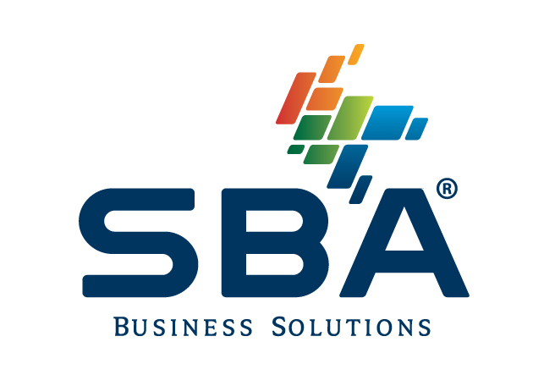 |  |  | 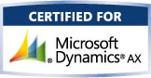

APS Automaterialen in the Netherlands is a member of Autodistribution (AD), the largest wholesaler and distributor of car parts in Europe. They provide supplies and services to 19 national partners representing 500 different AD distributors who, together, have a network of 2,200 auto parts establishments across 26 European countries. When their text-based system that ran on a UNIX server became too much of an obstacle, they selected the Wholesale solution for Microsoft Dynamics® AX from SBA Business Solutions. They now are completely integrated with their buying association, AD Nederland, and have automated communications and transactions with suppliers and customers.

Although their solution was stable, APS was dissatisfied with several critical areas, including the lack of resources available to maintain and update the system, and their inability to automate communications and transactions with customers and suppliers.

Solution
After an in-depth review of six competitive solutions, APS selected the Wholesale for Dynamics AX solution from SBA Business Solutions because it met their industry-specific needs, and because it was being used by their buying association, AD Nederland, and several other companies within their supplier network.

Benefits
With the new solution in place, APS has fully automated sales transactions and inventory management. As a result, they were able to free up three front desk employees. In addition, they are operating more efficiently overall due to the availability of real-time, relevant business intelligence that can easily be shared across the organization.

The total solution is being implemented in phases. Still at the early stages, more than 69 users are enjoying the benefits of the easy-to-use solution that helps them improve their productivity and better serve their suppliers and customers. Future plans for APS and SBA Business Solutions include integrating processes with additional suppliers, such as electronic invoicing.

You can read more about the Wholesale for Microsoft Dynamics AX solution that APS Automaterialen chose in the Microsoft Dynamics Marketplace.

