For more information about other Microsoft customer successes, please visit: www.microsoft.com/casestudies
Customer: Trion
Web Site: www.trion.com
Customer Size: 300 employees
Country or Region: United States
Industry: Professional services
Partner: Neudesic

Customer Profile
Trion is an employee benefits consulting firm based in Philadelphia, Pennsylvania, that develops innovative benefit solutions for local, regional, and Fortune 1000 companies.

Software and Services
- Microsoft Dynamics
- Microsoft Dynamics CRM Online
Microsoft Dynamics
Customer Solution Case Study
Benefits Consultant Doubles Efficiency with Online CRM Solution

“It would have taken 70 hours a month to get the pre-opportunity data that now is just there in the system. Our efficiency has soared by well over 100 percent with Microsoft Dynamics CRM Online.”
Jeff Kiely, Vice President of Sales and Marketing, Trion
Trion, an employee benefits consultant, was eager to switch from GoldMine to Microsoft Dynamics CRM. Not wanting to burden its overtaxed IT staff, Trion engaged with Neudesic, a Microsoft Gold Certified Partner, to help it deploy Microsoft Dynamics CRM Online in a matter of weeks. Today, Trion is pumping rich account data all over the company and has doubled efficiency, improved business insight, lowered costs, and improved its marketing.

Business Needs
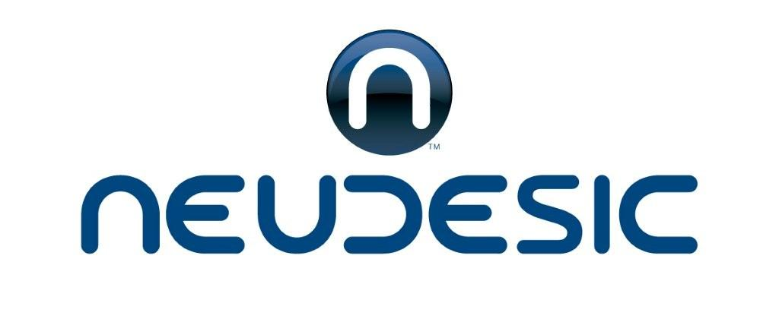 |  |  | 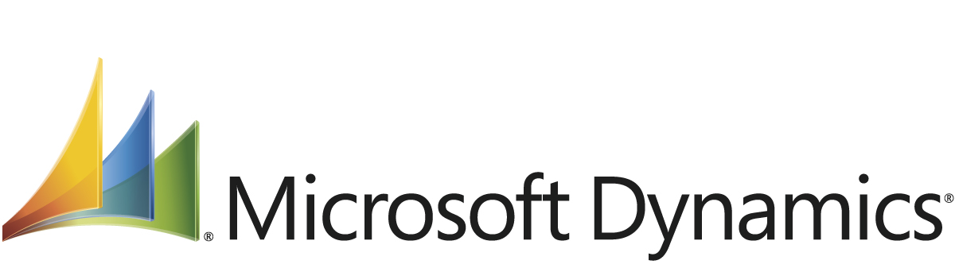

Trion is a Philadelphia, Pennsylvania–based health and benefits consultant that helps companies manage their healthcare expenditures while providing competitive employee benefits. Trion used GoldMine customer relationship management (CRM) software as its lead-tracking system but struggled with low adoption rates and limited collaboration among sales team members.

Employees spent the majority of their day working within the Microsoft Office Outlook 2007 messaging and collaboration client and did not like jumping back and forth between Office Outlook and GoldMine. Further, the sales staff felt that using these two disparate applications made for a clear duplicity of work, which prevented them from spending more time with customers.

“We wanted a system that could make our salespeople more productive and also help the business development staff manage calls, simplify forecasting, manage our marketing lists, and more, but first we needed a product that people would actually use,” says Jeff Kiely, Vice President of Sales and Marketing at Trion.

Solution
In mid-2007, Trion decided to switch from GoldMine to Microsoft Dynamics CRM, a full-featured customer relationship management system. The main motivation was to move to a Microsoft program that tightly interoperates with Office Outlook. Trion then began to look at deployment options and brought in Neudesic, a Microsoft Gold Certified Partner from Irvine, California, to provide guidance. “We had a small IT staff that was already overtaxed, and we did not want to implement Microsoft Dynamics CRM ourselves,” Kiely says.

Neudesic recommended Microsoft Dynamics CRM Online, a Microsoft-hosted version of Microsoft Dynamics CRM that provides the same power of the on-premises version of the program with a much faster implementation time. “Neudesic quickly grasped our business processes and translated them into CRM workflows,” Kiely says. “They took the whole technical burden off of us.”

Trion first rolled out Microsoft Dynamics CRM Online to its outside sales group. “Users really liked it,” Kiely says. “After we got that going, we expanded it to the business development people, then to account managers and marketing people.” Trion created workflows in Microsoft Dynamics CRM Online that automatically move and track sales opportunities and notify team members when actions are needed or steps have occurred. “Automated workflows really boost our efficiency because users don’t need to remember what they need to do; they are prompted by the software, or the software just takes care of sending an e-mail alert or sending a reminder,” Kiely says.

Trion is eager to integrate Microsoft Dynamics CRM Online with the Microsoft Dynamics GP software that it uses. Trion also had Neudesic build a tool based on the Microsoft Silverlight browser plug-in that salespeople use to quickly check off accounts in Microsoft Dynamics CRM Online. Neudesic hosts the code for this application through the Windows Azure platform.

Benefits
By adopting Microsoft Dynamics CRM Online, Trion was able to deploy a modern CRM system in weeks, for a fraction of the cost of an on-premises deployment. It has doubled sales efficiency, improved business insight, lowered costs with the online model, and gained instant feedback on marketing investments.

Efficiency Doubles
Thanks to automated workflows, a forecasting process that used to take four hours a week now takes 20 minutes a week, and Trion gets far more accurate data. “It would have taken 70 hours a month to get the pre-opportunity data that now is just there in the system,” Kiely says. “Our efficiency has soared by well over 100 percent with Microsoft Dynamics CRM Online.” Salespeople are able to make more sales calls every day and more accurately track their activities, which in turn puts more money in their pockets.

Better Business Insight
Managers have far better insight into deal status and business health. They can get an overview of where deals are in the sales process, so they can apply pressure at the right junctures to keep deals moving. “We wouldn’t be able to analyze and improve our sales process without Microsoft Dynamics CRM Online,” Kiely says. “We’ve also created a graphical, push-button report on sales year-to-date. Creating this before was a painful process involving a lot of spreadsheets.”

Rapid Implementation
An online solution also eliminated implementation work for Trion, whose IT staff did not need to spend time purchasing servers, deploying software, and maintaining an on-premises solution. “If we had rolled out the CRM ourselves, we would have been a whole year behind where we are today,” Kiely says. ”Also, the online deployment gave us much more flexibility in adding users gradually. We could start with a handful of users and grow our usage over time.”

Lower Costs
With Microsoft Dynamics CRM Online, Trion had lower deployment and ongoing maintenance costs. “Microsoft takes care of all updates and maintenance to the program behind the scenes; we don’t even have to think about it,” Kiely says. “I don’t have to pull our IT resources away from other tasks to tend to the CRM. I’d much rather have them supporting our clients than our CRM.”

Better Marketing Intelligence
Previously, it was difficult for Trion to segment prospect and customer lists for marketing campaigns and to track the success of marketing campaigns. Now, Trion can easily sort prospect links for mailings and link inquiries back to originating campaigns. “We can now get real ROI [return on investment] around our marketing campaigns,” Kiely says.

